Vocational Rehabilitation Technical Assistance Center - Targeted Communities

(Project E3)

Final Performance Report
PR/Award Number: H264F150003
Performance Period: 10/1/2015-8/31/2021
Submitted by Southern University Baton Rouge

This product was developed under a grant from the Department of Education, under Vocational Rehabilitation Technical Assistance Center-Targeted Communities, Assistance Listing Number 84.264F. However, those contents do not necessarily represent the policy of the Department of Education, and you should not assume endorsement by the Federal Government.

Table of Contents
Acknowledgement 4
Introduction and Background 6
Project E3 Partners 6
State Vocational Rehabilitation VR Partners 8
Program Description, Goals, and Objectives 9
Project Objectives 10
Defining Targeted Communities (TCs) 10
Defining Targeted Populations 11
Three Levels of Technical Assistance 11
Targeted Community Intensive Technical Assistance Selection and Development 12
Four-Phase Model of ITA Implementation 12
Evaluation Methods and Data Sources 18
RSA-911 Data 18
National VR Needs Assessment 18
Community-Based Participatory Research (CBPR) Project Activities, Outputs and Outcomes 19
Performance Measures 20
Government Performance and Results Act (GPRA) Measures 20
Project Measures 30
Sustainability and Systems Change 41
Project E3 Leadership Academy 42
Race, Disability, and Poverty on Employment in Milwaukee 43
Financial Empowerment Capacity Building 44
The National Clearinghouse of Rehabilitation Training Materials (NCRTM) 45
Challenges, Opportunities, Recommendations, and Conclusions 49
Challenges 50
Opportunities 53
Recommendations 54
Conclusion 57

List of Tables and Figures
Tables
Table 1. State Vocational Rehabilitation Programs Engaged in ITA through Project E3 9
Table 2. Table State Vocational Rehabilitation Agencies Engaged in ITA 14
Table 3. CoP Member Self-Identified Roles 30
Table 4. Overview of Searchable Project E3 Resources 32
Table 5. ITA States in Order of Selection PY2019 and PY2021 38

Figures
Figure 1. Project E3 Intensive Technical Assistance States 13
Figure 2. Needs Assessment of State VR Agencies Noting Key Challenges 17
Figure 3. Number of Individuals Applying to VR, Being Determine Eligible with an IPE and Receiving Services 19
Figure 4. Number of HLGNA Applicants to VR 19
Figure 5. Percentage of HLGNA Applicants Determined Eligible for VR 20
Figure 6. Percentage of Eligible HGLNA with Individual Plans for Employment (IPE) 21
Figure 7. Targeted Community (TC) Application, Eligibility, IPE, and Service Rates in State Programs Not Under Order of Selection (OOS) 21
Figure 8. Targeted Community Application, Eligibility, IPE, and Service Rates in State VR Programs Under an OOS With at Least One Category Open 22
Figure 9. Targeted Community Application, Eligibility, IPE, and Service Rates in State VR Programs Under an OOS with No Categories Open 22
Figure 10. Number of HLGNA in Targeted Communities Successfully Closed in CIE 23
Figure 11. Percentage of HLGNA Consumers in Targeted Communities Exiting with CIE 24
Figure 12. HLGNA Employment Rate Compared to Entire TC 24
Figure 13. Number of Organizations Providing Services as a Result of Project E3 Capacity Building, Training and TA Activities (Cumulative) 25
Figure 14. Number of Formal Agreements Initiated Through Project E3 (Cumulative) 26
Figure 15. Number of Organizations in Partnerships Initiated Through Project E3 (Cumulative) 26
Figure 16. Number of Participants Engaged in Online Training by Project Year 27
Figure 17. Participation in Online Training by Organization Type 28
Figure 18. Online Training Participants by Job Title 28
Figure 19. Participation in Online Training by State or Territory (Representative Sample) 29
Figure 20. Number of Community of Practice (CoP) Participants Across Project Years 29
Figure 21. Number of Participant Website Sessions Across Project Years 31
Figure 22. Number of Social Media Views as a Project Engagement Measure 31
Appendix A - ITA State Profiles in Alphabetical Order

California 61
Illinois 68
Kentucky 75
Louisiana 81
Montana 88
New Hampshire 94
New Jersey 100
New Mexico 107
North Carolina 113
Oregon 122
South Carolina 129
Virginia 135

...

Department of rehabilitation and
Disability studies
230 Blanks Hall
Baton Rouge, Louisiana 70813

Phone: 225-771-2667
Fax: 225-771-3020

Acknowledgement
First, we would like to acknowledge Dr. Alo Dutta, founding Principal Investigator of Project E3. Without her tireless effort, this project would not exist. She initially approached me with her vision for a Technical Assistance Center which will:
- Educate State Vocational Rehabilitation Agencies personnel and their partners (Community Rehabilitation Programs and Community Based Organizations) better to serve consumers from traditionally underserved and unserved communities.
- Empower underserved and unserved consumers with the knowledge to increase participation so that they can take advantage of the available vocational rehabilitation services; and
- Employ these consumers in Competitive Integrated Employment, Supported Employment, and Self-Employment to increase community participation, create more inclusive communities and enhance the overall quality of life.
The project's name is a mouthful, the Vocational Rehabilitation Technical Assistance Center for Targeted Communities (VR-TAC-TC). To describe her vision succinctly, she coined Project E3: Educate, Empower, and Employ. Dr. Dutta served as the Principal Investigator until her untimely death on June 29, 2018. In reading this final report, we hope you will recognize that Dr. Dutta's vision and project objectives have exceeded even her high standards. We had the privilege of knowing and working with her, and we believe that she would be proud of the project's outcomes. Dr. Dutta will always have a special place in her students' and colleagues' hearts, as she has touched many lives throughout her life and career.
We would also like to express our sincere thanks and appreciation to Dr. Sandy DeRobertis. He has a long and distinguished career in Rehabilitation Services Administration (RSA) and the vision to develop a Technical Assistance Center to explore and develop strategies with a specific focus on the needs of the country's most marginalized and socio-economically disadvantaged people with disabilities. Because of his work, the original Request for Proposal (RFP) was announced to establish the Vocational Rehabilitation Technical Assistance Center for Targeted Communities (VR-TAC-TC).
We further owe our gratitude to Mr. Felipe Lulli, Project Officer, Rehabilitation Services Administration, for his enthusiastic support and guidance. Mr. Lulli was instrumental in implementing this project from start to finish and challenged us to be creative in serving marginalized people with disabilities.
Additionally, our University project partners, State VR, rehabilitation Counselors, consumers, and community partners deserve commendations for their diligence in organizing activities in their respective Targeted Comunities (24 in 12 states) and lending their time, insight, and perspective to make this project a success.
Finally, I would like to extend my deepest gratitude and appreciation to the Southern University Project E3 Leadership Team: Dr. Susan Flowers, who took over the helm as the Princical Investigator; Mr. John Walsh, Project Manager; and Ms. Karen Simms, Program Manager. The team went above and beyond planning and organizing training activities, maintaining partnerships, and keeping the program on track. Ms. Simms, in particular, deserves special commendations for her diligent work in managing the financial aspects of the project, her support role with the program activities, and as a liaison during the illness of Dr. Dutta in communicating her vision to colleagues.
We hope that you find the Final Report helpful in your daily practice of serving people with disability from marginalized backgrounds and harnessing community resources to provide quality services to those who deserve the most.

With regards,

Introduction and Background
The purpose of this report is to provide an overview of the Vocational Rehabilitation Technical Assistance Center-Targeted Communities (VRTAC-TC) project, technical assistance provided, partners and sites involved, evaluative efforts, and resulting outcomes. The VRTAC-TC, referred to herein as Project E3, was designed to emphasize "Educating, Empowering, and Employing" diverse groups of stakeholders with a focus on improving collaboration between VR and community partners to positively impact employment outcomes for historically underserved and/or marginalized individuals with disabilities residing in low-income communities.
This work represents the efforts and commitment contributed by project site staff, technical assistance project partners, state vocational rehabilitation (VR) personnel and community stakeholders, and the Rehabilitation Services Administration (RSA). Findings, discussions, and recommendations regarding how the process and outcomes can be used to guide program improvement and decision-making moving forward are presented.

Project E3 Partners
An experienced and knowledgeable cadre of individuals representing nine universities and organizations collaborated to design and implement the required elements of the project. Faculty and staff at Southern University provided oversight and leadership to guide and monitor efforts with and among partners. In addition to Southern University, the University of Wisconsin-Madison, the University of Wisconsin-Stout Vocational Rehabilitation Institute, the George Washington University, the University of Illinois at Urbana-Champaign, and the University of Kentucky served as primary partners responsible for the provision of technical assistance in assigned states and evaluation efforts.
Personnel from the Council of State Administrators of Vocational Rehabilitation (CSAVR) served as liaisons with the state vocational rehabilitation (VR) programs on behalf of the project and provided key guidance regarding the needs and considerations of VR programs engaging in all forms of technical assistance offered through Project E3. This included collaborating with the Currents team through the University of Arkansas in important activities designed to enhance cultural awareness, responsiveness, and sustainability. Employment Resources, Inc. (ERI) provided expertise in technical efforts regarding website development and management, online Communities of Practice (CoP), graphic design and branding of all project products, and enhancing accessibility throughout all online and web-based information and materials. Mr. Felipe Lulli served as the Project Officer and actively provided guidance, oversight, and support throughout the project period.
The following individuals, noted by affiliation, served in key roles throughout the course of the project:

Rehabilitation Services Administration
Mr. Felipe Lulli, Project Officer
Southern University
Dr. Madan Kundu, Project Director
Dr. Alo Dutta, Principal Investigator (October 2015-June 2018)
Dr. Susan Flowers, Principal Investigator (June 2019-August 31, 2021)
Mr. John Walsh, Project Manager
Ms. Karen Simms, Program Manager
The University of Wisconsin-Madison
Dr. Timothy Tansey
Dr. Fong Chan
Dr. Malachy Bishop
The University of Wisconsin-Stout
Mr. Kyle Walker
Dr. Cayte Anderson
Dr. Mary McManus
Mr. Terry Donovan
Ms. Elizabeth Gaertner
Ms. Jennifer Gundlach Klatt
Ms. Heidi Decker-Mauer

The George Washington University
Dr. Maureen McGuire-Kuletz
Dr. Kenneth Hergenrather
Ms. D. J. Ralston
The University of Illinois at Urbana-Champaign
Dr. David Strauser
The University of Kentucky
Ms. Christina Espinosa Bard
Dr. Malachy Bishop
The Council of State Administrators of Vocational Rehabilitation
Mr. John Connelly
Ms. Theresa Hamrick
Employment Resources, Inc.
Ms. Theresa Kulow
University of Arkansas-Currents
Ms. Robin Freeman

State Vocational Rehabilitation Partners
The state vocational rehabilitation programs also served key roles as partners in identifying needs and supporting the implementation of technical assistance efforts within and across states. State, regional, and local personnel from the VR programs were instrumental in these processes. Each Project E3 university partner was responsible for engaging and providing intensive technical assistance with at least two state VR programs. Certain states have both General and Blind VR agencies, and two states opted to involve both in the project resulting in a total of 14 programs in 12 states. Furthermore, other key community-based organizations and related stakeholders were important collaborators throughout the project and are highlighted in the appendices.
Table 1. State Vocational Rehabilitation Programs Engaged in ITA through Project E3
State VR Agency | Project E3 Partner | Agency Designation | Census Region-Division
- California Division of Vocational Rehabilitation | UIUC | Combined | West-Pacific
- Illinois Division of Rehabilitation Services | UIUC | Combined | Midwest-East North Central
- Kentucky Office of Vocational Rehabilitation | UK | Combined | South-East South Central
- Louisiana Rehabilitation Services | Southern University | Combined | South-West South Central
- Montana Vocational Rehabilitation and Blind Services | UW- Madison | Combined | West-Mountain
- New Hampshire Bureau of Vocational Rehabilitation | UW-Stout | Combined | Northeast-New England
- New Jersey Vocational Rehabilitation Services | GWU | General | Northeast-Middle Atlantic
- New Mexico Department of Vocational Rehabilitation | Southern University | General | West-Mountain
- North Carolina Vocational Rehabilitation Services | UW-Stout | General | South-South Atlantic
- North Carolina Vocational Rehabilitation for the Blind | UW-Stout | Blind | South-South Atlantic
- Oregon Vocational Rehabilitation | UK | General | West-Pacific
- Oregon State Commission for the Blind | UK | Blind | West-Pacific
- South Carolina Commission for the Blind | UW-Madison | Blind | South-South Atlantic
- Virginia Department for Aging and Rehabilitative Services | GWU | General | South-South Atlantic

Program Description, Goals, and Objectives
The purpose of the Project E3 program was to increase vocational rehabilitation (VR) program participation levels and improve the employment outcomes of individuals with disabilities from selected traditionally underserved population groups living in economically disadvantaged communities across the United States. To this end, the Rehabilitation Services Administration (RSA) funded a cooperative agreement (CFDA 84.264F) to support the development and collaboratively guide these efforts.
Project E3 partners and staff facilitated linkages for State VR agencies through substantial outreach to partner agencies within targeted communities (TCs) to increase the resources and key partnerships needed to address daily stressors that often result in unsuccessful VR case closures, including childcare needs, homelessness, hunger, safety concerns, interpersonal issues, and lack of transportation, basic or remedial services, and literacy services.
Training and technical assistance efforts focused on developing and providing opportunities for ongoing discussion with rehabilitation professionals from both (1) State VR agencies and partner agencies serving the targeted communities, and (2) diverse service providers throughout the nation who work with the selected or targeted populations in the TCs or in other economically disadvantaged communities similar to the TCs.
In this project, targeted populations are called High Leverage Groups of National Applicability, or HLGNAs. (Refer to the following page for more information about HLGNAs.)
Formal and informal partnerships among relevant stakeholders were developed, including but not limited to, state and local social service and community development agencies, correctional facilities, community rehabilitation programs (CRPs), school systems, and employers with the aim of:
- Increasing referrals to the State VR system for economically disadvantaged individuals with disabilities from at least two high-leverage groups with national applicability residing in each of the targeted communities; and
- Facilitating the provision of support services by stakeholders to VR consumers and applicants from at least two high-leverage groups with national applicability residing in each of the targeted communities.
Furthermore, partners worked with sites to develop and implement outreach policies and procedures based on evidence-based and promising practices to ensure that consumers with disabilities in each of the targeted communities were located, identified, and evaluated for services. Project E3 partners and the respective state partners developed and implemented collaborative and coordinated service strategies designed to increase the number of consumers with disabilities from targeted communities served by the State VR agencies, and receive support services from other stakeholders to obtain, maintain, regain, or advance in competitive integrated employment.

Project Objectives
The following project objectives were used to guide the center's activities throughout the project, including the no-cost extension period:
- Involve all 78 (formerly 80) state Vocational Rehabilitation agencies in the development of knowledge and selection of targeted communities.
- Collaboratively design modules and strategies including field-based, in-office, state-of-the-art communications strategies, and communities of practice for the provision of intensive, targeted, and general technical assistance and coordination activities to VR stakeholders serving economically disadvantaged persons with disabilities.
- Provide technical assistance to state VR agencies, their partners, and employers designed to maximize community support services in targeted communities, complement VR services, and promote competitive integrated employment consistent with informed choice for economically disadvantaged persons with disabilities from high-leverage groups of national applicability.
- Conduct formative and summative evaluations to measure and track the effectiveness of ongoing technical assistance, training, and alliance-building activities.

Defining Targeted Communities
For the purposes of this project, the term targeted community is defined as 'any economically disadvantaged community that would qualify as an empowerment zone. Empowerment zones are designated areas of high poverty and unemployment as defined by the U.S. Department of Housing and Urban Development and have a strategic plan that includes (1) a vision for change that identifies what the community could look like in the future and how it can achieve its goals, (2) a description of community-based partnerships that encourage all stakeholders to participate in achieving economic revitalization, (3) expanded economic opportunity through increased access to capital and credit for businesses and assistance with job training and placement for residents, and (4) sustainable community development that ensures economic, physical, and environmental factors are aligned as the community is revitalized. To be classified as an empowerment zone, the median income in the defined geographic area must be below 200% of the Federal poverty level. Furthermore, the unemployment rate in the defined geographic area must be at or above the national average.

Defining Targeted Populations
Targeted populations, also known as High Leverage Groups of National Applicability (HLGNA), are groups of individuals who have been underserved and/or achieve substandard performance in multiple locations across the country. For purposes of this project, individuals with disabilities representing these populations were further targeted based on disparities indicating outcomes of 65% or less of the VR agency's statewide outcome level regarding eligibility determination, service provision, and successful attainment of integrated employment outcomes. The key HLGNA groups included:
- Residents of rural and remote communities
- Adjudicated adults and youth
- Individuals with disabilities in foster care
- Individuals with disabilities receiving Federal Financial assistance
- Culturally diverse populations
- High school dropouts and functionally illiterate consumers
- Persons with multiple disabilities
- SSI and SSDI recipients
- Subminimum wage employees

Three Levels of Technical Assistance
Project E3 offered three distinct levels of technical assistance to state VR agencies, defined as Universal, Targeted, and Intensive. Each level was designed to serve a unique purpose in meeting agency and stakeholder needs.

Universal Technical Assistance (UTA)
UTA included resources and information made available on the Project E3 web and social media sites, including access to online training webinars, searchable promising and evidence-based resource materials, video conferences, and communities of practice.

Targeted Technical Assistance (TTA)
TTA services were based on common needs identified across agencies and included one-time, labor-intensive events, such as facilitating strategic planning or hosting regional or national conferences. TTA also encompassed episodic, less labor-intensive events that extended over a period of time, such as facilitating a strategically designed series of webinars or conference calls on single or multiple topics that are designed around the needs of the recipients.

Intensive Technical Assistance (ITA)
ITA involved the development of collaborative, ongoing relationships between Project E3 staff, the state VR agency, and community partners. Prior to the Covid-19 pandemic, ITA was often provided on-site using a coaching model and Project E3 and agency staff worked closely to develop intensive TA proposals, including developing, expanding, and supporting the growth of a Community Advisory Board for each Intensive TA effort. ITA was designed to facilitate changes to policy, programs, practices, or operations that increased state agency capacity and improved participation rates and employment outcomes for targeted populations at one or more system levels.

Targeted Community Intensive Technical Assistance Selection and Development
In the first year, each of the 78 state VR agencies was surveyed to identify key barriers and challenges experienced by individuals with disabilities representing the HLGNA populations. Following the comprehensive needs assessment process, VR agencies were invited to identify two or more groups of underserved individuals with disabilities from one or more targeted communities in each of their respective states. All identified targeted communities in each State met the eligibility requirements for designation as an Empowerment Zone under either 24 CFR 598.100 or 7 CFR 25.100.
ITA proposals (24 = 2 per state for 12 participating states) were then developed and presented to RSA for review. The proposals included communities reflecting national diversity with respect to state, region, and culture. Communities were situated in at least 12 states and territories located within no fewer than eight of the nine Census Divisions (state groupings) defined by the U.S. Census Bureau. No more than two targeted communities were located within any one state or territory, and no more than four were located within any one Census Division. Each targeted community proposal included:
- a map that showed the TC's boundaries and relevant demographic characteristics, including poverty concentration,
- documentation that within the TC's boundaries, the median household income was below 200% of the Federal poverty level, and the rate of unemployment was at or above the national annual average, and
- a performance chart of State VR agency data that documented substandard participation levels and performance outcomes achieved by VR consumers and applicants from high-leverage groups with national applicability (HLGNA) from the TC's in comparison to the State's overall performance. The data included (a) the number and percentage of the overall population; (b) the number and percentage of individuals determined eligible; (c) the number and percentage of individuals receiving VR services pursuant to an individualized plan for employment; (d) the number and percentage of individuals who service records were closed without employment; and (e) the number and percentage of individuals who service records were closed after achieving employment.
A total of 12 states representing 14 state VR agencies were approved to participate in ITA efforts.
Project E3 partners coordinated and provided ITA designed to empower state VR agencies and state and local partner organizations in improving outreach and employment-related services to underserved individuals with disabilities in 24 targeted economically disadvantaged communities across the 12 states. The teams leveraged promising practices, community knowledge, and close collaboration with key stakeholders to expand employment opportunities for individuals with disabilities representing underserved populations throughout the selected communities.
In addition to improving short-term engagement and employment outcomes in the targeted communities, longer- term goals of the project aimed to elevate awareness of the complex needs of individuals with disabilities representing historically underserved and/or marginalized populations living in low- income communities, build and strengthen partnerships between state VR and other key programs in serving these populations, and identify key strategies that state VR programs can use to help improve engagement and outcomes with similar disability populations and communities nationally.
The 12 states approved for ITA were California (Combined), Illinois (Combined), Kentucky (Combined), Louisiana (Combined), Montana (Combined), New Hampshire (Combined), New Jersey (General), New Mexico (General), North Carolina (Blind and General), Oregon (Blind and General), South Carolina (Blind), and Virginia (General). See Figure 1. Given that two of the ITA states engaged both a General and Blind program, a total of 14 state vocational rehabilitation agencies were represented across the 12 states. Table 2 denotes the state VR agencies and the Project E3 partner responsible for designing and implementing the respective ITA efforts.

Figure 1. Project E3 Intensive Technical Assistance States
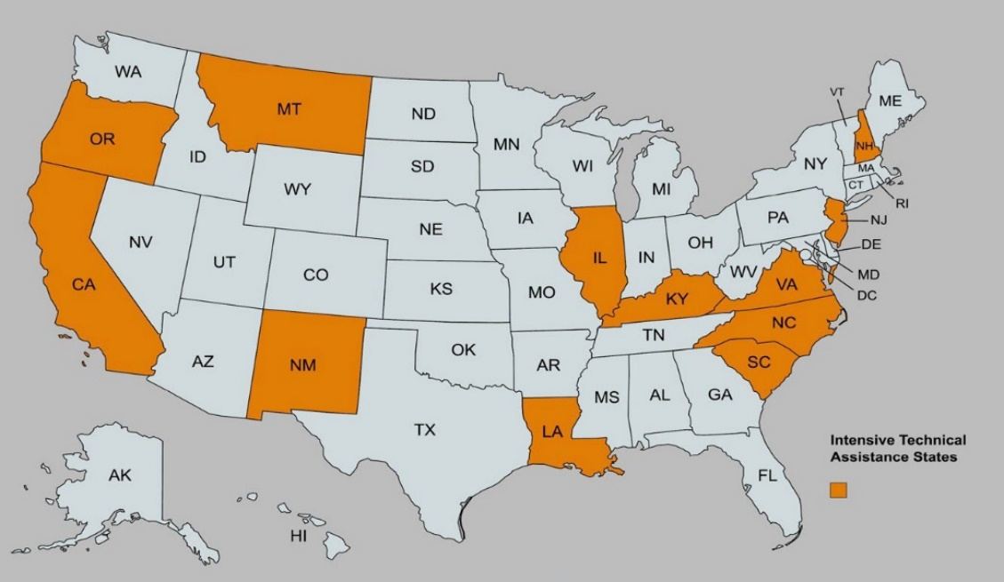

Table 2. State Vocational Rehabilitation Agencies Engaged in ITA
State VR Agency | Project E3 Partner
- California Division of Vocational Rehabilitation | UIUC
- Illinois Division of Rehabilitation Services | UIUC
- Kentucky Office of Vocational Rehabilitation | UK
- Louisiana Rehabilitation Services | Southern University
- Montana Vocational Rehabilitation and Blind Services | UW-Madison
- New Hampshire Bureau of Vocational Rehabilitation | UW-Stout
- New Jersey Vocational Rehabilitation Services | GWU
- New Mexico Department of Vocational Rehabilitation | Southern University
- North Carolina Vocational Rehabilitation Services-General | UW-Stout
- North Carolina Vocational Rehabilitation for the Blind | UW-Stout
- Oregon Vocational Rehabilitation-General | UK
- Oregon State Commission for the Blind | UK
- South Carolina Commission for the Blind | UW-Madison
- Virginia Department for Aging and Rehabilitative Services | GWU

Four-Phase Model of ITA Implementation
Intensive technical assistance was conceptualized as a series of four phases, with each phase building on the lessons learned and insights gained from the previous phase. Once the specific communities were identified, Project E3 partners worked closely with stakeholders in each of the local communities, providing intensive technical assistance to these communities in four distinct phases over the course of the five-year project. Each phase built upon the lessons learned and insights gained from the previous phase.
Phase 1: Community Outreach and Orientation for Target Populations
In Phase 1, the project focused on increasing the number of VR referrals and applications from HLGNA groups in the targeted community. Once the specific communities were identified, Project E3 partners worked closely with stakeholders in each of the local communities by providing intensive technical assistance across four distinct phases over the course of the five- year project.
The project focused on increasing the number of VR referrals and applications from HLGNA groups in the targeted communities through outreach to community-based organizations, as well as to potentially eligible individuals. This two-pronged approach served to increase the awareness of VR services in the community and increase the community-based organizations' capacity to identify and refer potentially eligible individuals. For example, one Project E3 partner developed a referral screening tool for use in the Chicago TC, which was then available for use in other communities. All outreach activities in each TC were adapted to fit the communities. Outreach efforts to individuals included orientation sessions that addressed the general lack of awareness of VR services and procedures, as well as issues specific to the community, such as lack of trust. Other examples of individual outreach included public service announcements specifically tailored to reach prioritized populations, community forums, listening sessions, social media polls, radio interviews, videos, podcasts, and literature distribution.
Phase 2: Community Needs Assessment and Strategies for Change
The purpose of the second phase was to identify barriers to VR participation and employment in these targeted communities, with the goal of working collaboratively with community stakeholders to develop strategies to address those barriers.
During the second phase, engaging the community was the overarching goal of the project. E3 partners worked with community stakeholders to identify barriers to VR participation and employment in each targeted community, with the goal of working together to then develop strategies to address those barriers, informing the work of the third phase.
Phase 3: Training and Technical Assistance for staff of State VR Agencies, Community Rehabilitation Programs, and Community-Based Organizations.
In this phase, Project E3 partners began offering training and technical assistance aimed at addressing gaps identified by ongoing community needs assessments. Overall, intensive technical assistance activities were designed to achieve improvements in the following areas for prioritized populations in the targeted communities:
- Referral sources and the applications stream to VR,
Capacity of VR counselors to engage and retain clients in the VR process,
- Capacity of community-based organizations (CBOs) to address barriers to VR participation and employment,
- Capacity of VR counselors to expand clients' employment opportunities, and
- Capacity of the VR agencies and CBOs to sustain promising E3 practices beyond the life of this grant.
Training on specific topics was geared towards bridging knowledge and skill gaps and improving the capacity of rehabilitation professionals to provide those VR services and comprehensive support, while also expanding employment opportunities for members of their prioritized communities. Project E3 partners provided training and technical assistance aimed at improving the capacity of service delivery professionals including state VR personnel as well as community rehabilitation programs and other community-based organizations with a specific focus on the intersection of disability and poverty affecting targeted populations. Examples of topical areas covered include:
- Service delivery to VR clients, including targeted populations.
- Coordinated community support services strategies.
- Expansion of employment opportunities for targeted populations

Phase 4: Sustainability and Systems Change
In the fourth and final phase, Project E3 partners focused on further developing and strengthening those collaborative relationships both with and between community stakeholders. The aim was to build the capacity of community-based organizations and community stakeholders to leverage their available resources to address barriers that might typically be considered beyond the scope of VR services, such as lack of housing, lack of transportation, food insecurity, inadequate healthcare patterns, and other systemic barriers to VR participation and employment.
With a focus on sustainability and systems change, the project further developed and strengthened collaborative relationships both with and between community stakeholders. This was done with the intent of building the community-based organization and community stakeholder capacity to leverage their available resources, to overcome some of the barriers that might be considered outside of the scope of VR services that had previously been identified, such as lack of housing, lack of transportation, food insecurity, inadequate healthcare patterns, and other systemic barriers to VR participation and employment.

Evaluation Methods and Data Sources
Multiple data sources were used to inform program evaluation efforts including process measurement and outcomes reporting throughout the project. Central to our project evaluation was having access to the RSA-911 data which enabled the project to track performance on a regular basis. The data was managed in an online data management portal, Salesforce, that allowed the project evaluators to conduct data analysis on outcomes for each quarter, as well as compile custom reports for project partners. Other sources of data for project evaluation involved quarterly reports provided by partners, surveys from participants in training and other initiatives, as well as documentation provided by State VR programs and community agencies to highlight formal changes in service collaboration and coordination. Information dissemination and participant engagement data analytics were tracked, compiled, and reported quarterly and annually throughout the project. And key informant interviews and focus groups were conducted with select ITA sites and TTA events to better understand participant perspectives and experiences.

National VR Needs Assessment
In close consultation with the other RSA-funded technical assistance centers, federal project officers, and key partners including CSAVR, project leadership actively engaged in the development of a joint needs assessment survey. The survey was disseminated to all 78 state vocational rehabilitation programs during Year 1 to gather VR perspectives regarding barriers to employment experienced by individuals with disabilities in their states and used this information to guide subsequent TA efforts across the centers. The top five concerns limiting service provision or economic opportunities of people with disabilities included a lack of employer networks, lack of self-employment [opportunities], pervasive poverty stressors, lack of high-quality jobs, and lack of transportation. See Figure 2.
Figure 2. Needs Assessment of State VR Agencies Noting Key Challenges
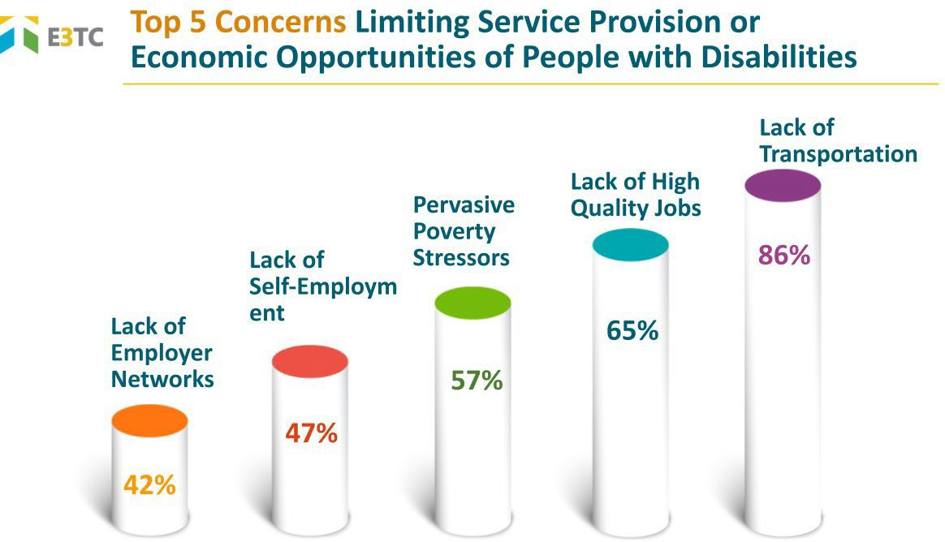

Community-Based Participatory Research (CBPR)
Community-Based Participatory Research (CBPR) is an established research method that emphasizes the importance of engagement and collaboration between researchers and the community for whom the research or program is ultimately meant to serve. Project E3 used elements of CBPR across all phases of the project with states receiving ITA. E3 partners worked in collaboration with community stakeholders to identify their needs and implement the most appropriate strategies to address those needs. Local community experts were invited to engage and assist in hosting focus groups, listening sessions, and convening advisory councils.

Project Activities, Outputs, and Outcomes
Though each state and community identified different needs through the national needs assessment process, specific areas of overlap included:
- A general lack of awareness of VR services,
- Lack of a relationship between community-based organizations (CBO) and VR, and
- External barriers such as transportation, lack of employment opportunities, and other specific issues relevant to the community.
Project E3 partners used this information to guide discussions with state VR agencies in identifying state-specific needs and design training and technical assistance to align and build capacity in addressing the areas. Consistent with the project's logic model and accompanying work plans, a series of high-quality activities, outputs, and outcomes were identified. Topical areas focused on activities and products aligned with technical assistance needs identified by VR practitioners, agency leadership, and community stakeholders.

Performance Measures
The final priority for the project defined the required performance measures. These included the Government Performance and Results Act (GPRA) and non-GPRA measures (i.e., project and program measures). The cooperative agreement further specified the short-term and long-term measures used in assessing performance against the goals and objectives of the project and the outcomes.
- Increase the participation in State VR programs of individuals with disabilities from low- income communities.
- Increase the number and percentage of individuals with disabilities from low-income communities served through the State VR programs that complete their VR program and enter into competitive integrated employment.
- Increase the amount of community support services provided to individuals with disabilities from low-income communities who are participating in a VR program from community agencies and support systems.
- Develop collaborative, coordinated service strategies among State VR programs and community support service agencies and systems to provide more comprehensive services to individuals with disabilities from low-income communities who are engaged in a VR program.

Government Performance and Results Act (GPRA) Measures
Project evaluation was based on data from multiple sources. Central to the project evaluation was quarterly RSA-911 data that enabled the project to track performance on a regular basis. RSA-911 data was held in an online data management portal, Salesforce, that allowed the project evaluators to conduct data analysis on outcomes for each quarter, as well compile custom reports for project partners. Other sources of data for project evaluation were quarterly reports provided by partners on ITA activities, surveys from participants in training and other initiatives, as well as documentation provided by State VR programs and community agencies to highlight formal changes in service collaboration and coordination.
The outcomes identified for the project were to work with individuals with disabilities from low- income communities toward increasing participation in State vocational rehabilitation programs, increasing the number and percentage of individuals with disabilities served through the State VR programs that exited in competitive integrated employment; increasing community support services; and attempting to develop collaborative, coordinated service strategies among State VR programs and community support services agencies and systems to provide more comprehensive services. Note: All data is presented in VR Program Years – June 30 through July 1 – unless otherwise noted.

GPRA Measure One: Increase Participation in State VR and Employment Rates of Individuals with Disabilities Representing HGLNA from Low-Income Communities.
Project E3 worked with state VR agencies in 12 states to increase the representativeness of high- leverage groups of national applicability in targeted communities. Throughout the project, 5,243 individuals from the identified HLGNA in these communities applied for services. Of this sample, approximately 99% were found eligible for services. However, of those found eligible, only 34% had an IPE (Individualized Plan for Employment) developed, and the majority of those with IPEs were ultimately served. Of note, as the time from application to closure was generally greater than 700 days, many of the individuals that applied during the course of the project are still being served by the VR programs.
Figure 3. Number of Individuals Applying to VR, Being Determined Eligible, with an IPE, and Receiving Services
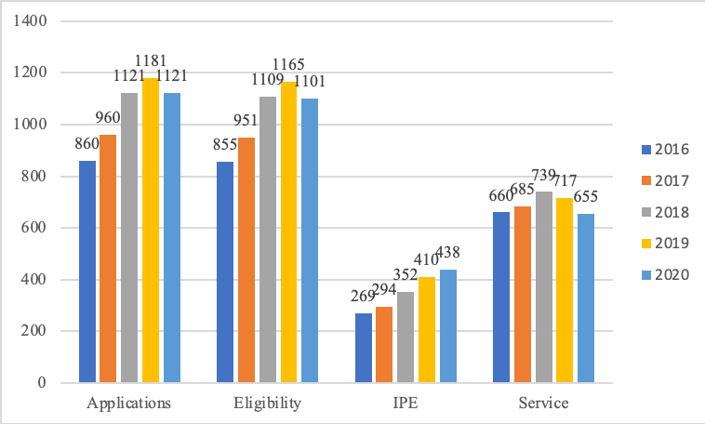
GPRA Measure 1.a. Increase the Number of HLGNA Individuals Applying to VR
Throughout the project, a relatively stable trend reflecting the proportional number of applications of HLGNAs in both specifically targeted communities as well as the entire state of those VR agencies served under an intensive technical assistance agreement emerged. However, the proportion of HLGNAs in the targeted communities outpaced the proportion of HLGNA applications in the rest of the ITA States through the end of the project year 2018. The number of applicants increased from 860 to 1,181 between 2016 and 2019, then declined between 2019 and 2020 (see Figure 3).
The downward trend in applications in 2020 by HLGNA was consistent with overall downward statewide trends in applications to VR programs. The drop in applications is attributed to the Covid-19 pandemic as most state VR programs experienced a dramatic reduction in program applicants starting in March 2020, affecting both Quarter 3 of 2019 and continuing through the end of the project.

Figure 4. Proportion of HLGNA Applicants to VR

GPRA Measure 1.b. The Percentage of Applicants Deemed Eligible for VR
The percentage of applications by HLGNAs in the targeted communities determined eligible for VR services increased almost 5% over baseline. Those in the targeted communities were 7% more likely to be found eligible than HLGNAs served in the rest of the state. This suggests that intentional outreach efforts to HLGNAs in targeted areas may result in an applicant pool more likely to be found eligible for VR. An immediate downward trend in eligibility determination mirrored the decline in applications due to the Covid-19 pandemic beginning in the third quarter of 2020 and continued through the remainder of the project.
Figure 5. Percentage of HGLNA Applicants Determined Eligible for VR

GPRA Measure 1.c. The Percentage of Eligible Applicants with an Individual Plan for Employment (IPE)
The percentage of HLGNAs in targeted communities with IPEs also outpaced those in the rest of the states without ITA agreements. The growth in the proportion of those with IPEs was retained, and the HLGNAs in TCs closed the gap with respect to their counterparts in the other areas of their respective states, from an 11 percentage-point baseline gap (18% vs. 29%) to parity in 2018 (Figure 6). Of note, due to several factors, including potential order of selection, the proportion of those with IPEs is less than the proportion of those determined eligible. That is, toward the end of 2017, we observed the start of a decrease in the percentage of eligible applicants that were served under an IPE. The decrease in the percentage of those with an IPE appeared to facilitate a corresponding decrease in applications in subsequent quarters among HLGNAs.
Similar to the percentage of individuals with IPEs, the percentage of HLGNAs in TCs served under an IPE also outpaced those in the rest of the states without ITAs.
The growth in the proportion of those served under an IPE in the TCs, though decreasing overall proportion through 2018, was served at a higher rate than HLGNAs in the rest of the state through 2018. Again, of note, due to several factors, including order of selection, the proportion of those served under an IPE is less than the proportion of those determined eligible and those with IPEs. Interestingly, while the overall trend was downward, the gap between the HLGNA populations in the targeted communities, when compared with the rest of their respective states, was significantly narrower at project’s end than at baseline (3% vs. 11%).
Figure 6. Percentage of Eligible HGLNA with Individual Plans for Employment (IPE)

As noted earlier, there was a decrease in the percentage of eligible applicants who completed an IPE and were subsequently served under that IPE throughout the course of the project. One potential explanation is the impact of an order of selection that was implemented in different state VR programs. Figures 7, 8, and 9 note the corresponding changes in the proportion of the HLGNAs in the TCs across three time periods.
The first graph represents the three-state VR programs that were not under an order of selection. The second graph represents the seven states receiving ITA that were under an order of selection with at least one category open. The third graph represents the two-state VR programs receiving ITA that are under an order selection with no categories opened.
As noted in the graphs, among states without an order of selection, although the proportion of applicants is slightly down, and the percentage found eligible is approximately the same over time, the retention of HLGNA in service categories has increased across the project. Among states with an order of selection, but with categories open, there was a clear increase in those with an IPE in receiving services going into 2017 but yielding those gains in 2018. Lastly, in those states with an order of selection in all categories closed, despite modest increases from 2016 to 2017, all category measures declined through 2018.

Figure 7. Targeted Community Application, Eligibility, IPE, and Service Rates in State VR Programs Not Under an Order of Selection (OOS)
2016 2017 2018
Application Eligible IPE
Service

0.36
0.34
0.32
0.3
0.28
0.26
0.24
0.22
0.2

Figure 8. Targeted Community Application, Eligibility, IPE, and Service Rates in State VR Programs Under an OOS With at Least One Category Open

2018
2017
2016
0.11
0.1
0.09
0.08
0.07
0.06
0.05
0.04
Orange line = Application Black line = Eligible Light Gray line = IPE Dark Gray line = Service

Figure 9. Targeted Community Application, Eligibility, IPE, and Service Rates in State VR Programs Under an OOS with No Categories Open
2018
2017
2016
0.5

0.45

0.4

0.35

0.3

0.25

0.2
TC in State VR Under an Order of Selection with NO Categories Open
Orange line = Application Black line = Eligible Light Gray line = IPE Dark Gray line = Service

GPRA Measure Two: Increase the number and the percentage of individuals with disabilities from low-income communities that achieve competitive integrated employment (CIE).
There were two outcomes of interest regarding competitive integrated employment. First, we focused on increasing the number of participants achieving competitive integrated employment outcomes in the targeted communities. Second, TA efforts aimed to increase the employment rate among HLGNAs in these communities.

GPRA Measure 2.a. The Number of Individuals with Cases Closed Successfully with CIE After Receiving VR Services.
In reviewing the total number of closures after an IPE and employment, a total of 773 individuals representing HLGNA populations in the targeted communities were successfully closed with competitive integrated employment between 2017 and 2020 (see Figure 10.a). A total of 16,431 individuals representing HLGNA populations in the other areas of the states engaged in the VRTAC-TC project exited in employment after being served under an IPE (see Figure 10.b).

Figure 10.a. Number of HLGNA in Targeted Communities Successfully Closed in CIE
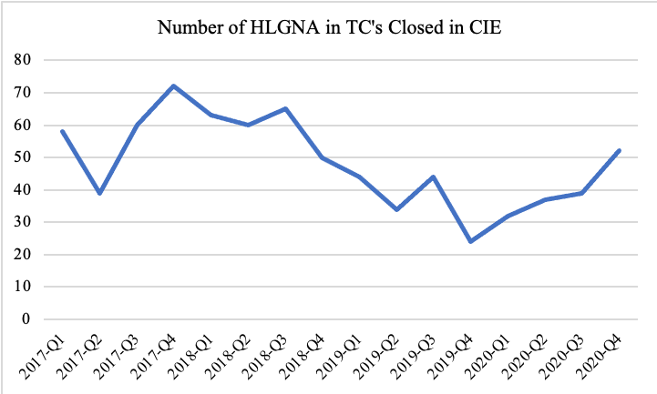
Figure 10.b. Number of HLGNA in rest of the TC states Closed in CIE

Noticeable in Figures 10.a and 10.b, comparable fluctuations over time were evident in the number of HLGNA individuals exiting in employment after an IPE. However, in evaluating the relative proportion of HLGNAs exiting in employment relative to the total number exiting in employment in both the TC area and across the remaining areas of those states involved in the TC project, those served in the targeted communities appear to show a reversal of a downward trend that began in 2017 to an overall increase going into 2018 and continuing into 2019.
One outcome of interest, distinct from the rehabilitation rate, was to increase the HLGNA members who exit in employment after an IPE as a proportion of all individuals exiting in employment, in both the targeted communities and the other areas of the state. By increasing efforts to serve HLGNAs, it was anticipated that the HLGNAs would represent an increasing proportion of those who exited in employment within the TCs.
Figure 11 shows that, in general, the proportion of HLGNAs exiting in employment in areas of the state outside of the TCs remained relatively unchanged over time. However, the proportion of the HLGNA populations who exited in employment within the TCs, although comparable through 2017 and early 2018, was overall almost eight percentage-points higher (23% vs.15%) than the HLGNA populations who exited in employment in the other areas of their respective states by the fourth quarter of 2019. Relative to baseline, this represents an approximately 9 percentage-point increase (from two percentage-points below to seven percentage-points above) in the proportion of HLGNAs exiting in employment in the TCs compared to the HLGNAs exiting in employment elsewhere in the respective states.
Figure 11. Percentage of HGLNAs in Targeted Communities and E3 States Exiting with Employment

GPRA Measure 2.b. The Percentage of Individuals Exiting the VR Program with CIE After Receiving Services (Rehabilitation Rate).
Regarding the rehabilitation rates, Figure 12a shows that the overall gap between HLGNAs in the targeted communities and the HLGNAs served elsewhere in the respective states decreased from approximately 7.3 percent at baseline (33.4% vs. 40.7%) to 1.1 percent in 2020 (36% vs. 37.1%). See Figure 12.a., below. Notably, the HLGNA rehabilitation rate in the TCs increased by nearly three percent between baseline and the final project year (including a nearly seven percent increase between 2019 and 2020), despite the impact of the Covid-19 pandemic. The percentage of successful VR exits by HLGNA in the other areas of the state generally declined from baseline through 2020.

Figure 12a. HLGNA employment rate in TC and rest of State
When comparing rehabilitation rates within the targeted communities, Figure 12b shows that, while the HGLNAs’ rehabilitation rates were consistently lower than the rates for the other individuals served in the TCs, the gap between HLGNAs and non-HLGNAs in the TCs decreased by almost two percentage points between PY 2017 (33.2% vs. 40.2%) and 2020 (29.9% vs 35.2%). Appreciable gains from training and practice take time, yet these results may be an early and positive indication of Project E3 training effects, which may have mitigated the vocational rehabilitation impact of the pandemic on the HLGNA populations.
Figure 12b. HLGNA Employment Rate Compared to Others Within the TC
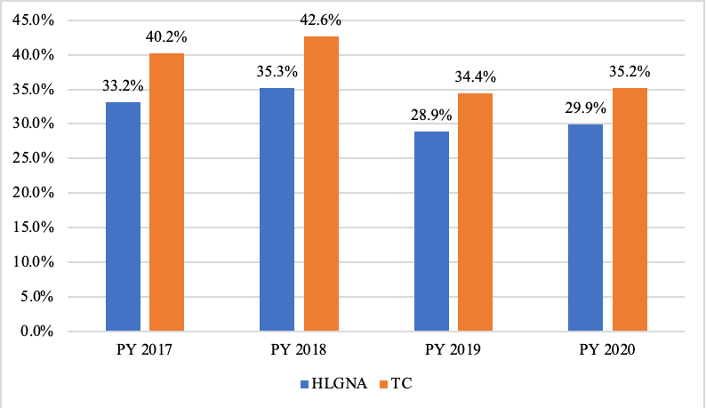
GPRA Measure 2.c. The Median Weekly Earnings of Individuals Achieving CIE.
The median weekly earnings of HLGNA in the targeted communities declined approximately 11% between 2017 and 2020. The median weekly earnings of the HGLNA in the targeted communities was approximately 16% lower than comparable HLGNA groups statewide consistently throughout the project. Median earnings of HLGNA in the targeted communities ended at $273.45 per week in 2020. The difference in the median earnings between 2017 and 2018 was -$26.34, increased by $12.77 in 2019 and declined by $21.66 in 2020. The downward trend in 2020 is likely related to Covid-19 as HLGNA populations were more likely than others to be employed in front-line service positions which were disproportionately impacted by unanticipated pandemic closures, hour reductions, and similar factors.

GPRA Measure Three: Increase the Support Services Provided by Community Agencies to Individuals with Disabilities from Low-Income Communities Who Participate in the VR Program.
GPRA Measure 3.a. The Number of Community Rehabilitation Programs, Community-Based Organizations, and Other Organizations Providing Direct Support Services As a result of the Project's Capacity-Building, Training, and TA Activities.
Community support services were defined as community building, leveraging available services and supports, and increasing connections with vocational rehabilitation agencies. Specifically, project evaluators tracked the number of organizations providing direct support services as a result of Project E3 capacity building training and technical assistance activities.
Figure 13 denotes the number of new organizations providing direct support services to VR consumers as a result of Project E3, which increased by 121 between Years One and Five of the project.

Figure 13. Number of Organizations Providing Services as a Result of Project E3 Capacity-Building, Training and TA Activities (Cumulative)
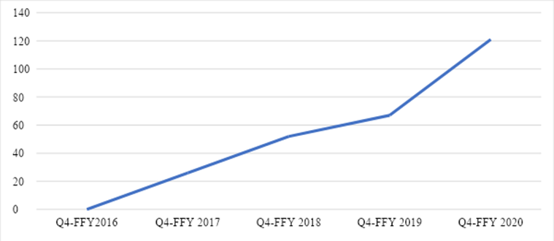

GPRA Measure Four: Increase Coordinated VR Program/Community Agency Service Delivery Systems and Strategies Providing Comprehensive Supports to Individuals with Disabilities from Low-Income Communities Who Participate in the VR Program.
GPRA Measure 4.a. The number of formal comprehensive supports partnerships among VR agencies, community rehabilitation programs, community-based organizations, and others initiated through the project.
The number of formal comprehensive support partnerships among VR agencies, community rehabilitation programs, community-based organizations, and other organizations that were initiated through Project E3 actions. Examples of these include formal agreements, contracts, and documented policy changes. The number of organizations involved in partnerships initiated through Project E3 was also measured. Figure 14 highlights the number of formal comprehensive partnerships among VR agencies and other community partners achieved through the project, which increased by 65 throughout the course of the project.

Figure 14. Number of Formal Agreements Initiated Through Project E3 (Cumulative)
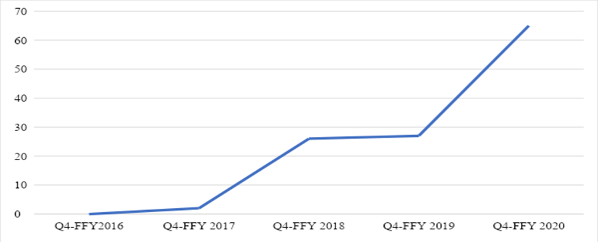
GPRA Measure 4.b. The Number of Organizations Involved in Partnerships Initiated Through the Project.
In addition to the formal partnerships initiated through the project period, the number of informal partnerships between VR, community rehabilitation programs and other community-based organizations also significantly increased. The line in Figure 15 shows the number of organizations in less formal partnerships with VR agencies, which increased by 368 throughout the project.
Figure 15. Number of Organizations in Partnerships Initiated Through Project E3 (Cumulative)
Q4-FFY 2020
Q4-FFY 2019
Q4-FFY 2018
Q4-FFY 2017
Q4-FFY2016
400

350
300

250

200
150
100

50
0

Project Measures

Measure 5 (Project): Project-specific performance measures focused on participant engagement, project reach, and sustainability efforts.
Project Measure 5.a. Number of state VR agencies participating in ITA.
The project partners were required to formally engage a minimum of 12 state VR agencies in ITA agreements throughout the course of the initiative. A total of 14 state VR agencies were engaged across 12 states, thus successfully meeting this measure.
Project Measure 5.b. Number of participants engaged in online training.
A primary aim of the Project E3 initiative was to actively and intentionally engage agency and program partners across a range of systems to build awareness and capacity in employment- focused service delivery to individuals with disabilities living in low-income communities.
The project developed and delivered 42 online webinar training opportunities featuring a variety of evidence-based practices, promising practices, and emerging practices demonstrated to be effective when working with underserved and unserved targeted populations. The online training was free of charge, and Certified Rehabilitation Counselor (CRC) continuing education units (CEU) were available to participants at no cost. Webinars were subsequently archived and available for ongoing access through the project website. The online training series launched in Year 2, accelerated through Year 5, and was completed during the No Cost Extension period. Across all project years, a total of 44,080 participants engaged in online training.
Figure 16. Number of Participants Engaged in Online Training by Project Year
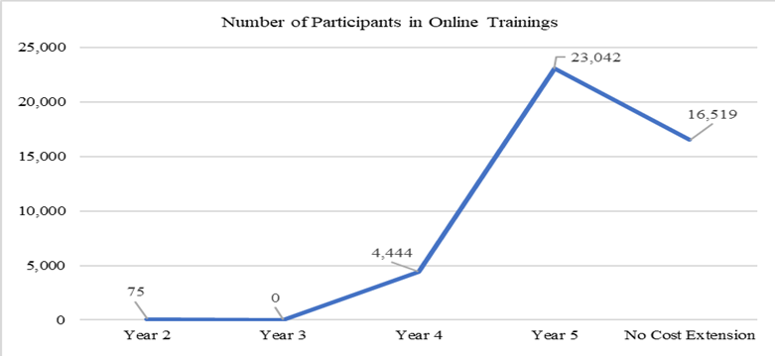

The industry norm for a percentage of registrants who eventually attend webinars is typically between 40% and 50%. Project E3 percentage exceeded the industry norm for each of the webinars offered, averaging a 69% attendance rate indicating the topical content was relevant and of particular interest during this period.
The top five webinar topics gaining the highest registration and attendance rates were (a) Customized Employment and a focus on Discovery process fidelity, (b) trauma-informed care, (c) the intersection of disability and poverty, (d) Social Security benefits with an emphasis on working with individuals receiving Supplemental Security Income (SSI), and (e) the use of Motivational Interviewing techniques within VR.
Given that a key aim of the project was to increase awareness and engagement with VR consumers, project staff tracked the representativeness of participants by organization type.
Most participants (74%) reported being employed by a state VR agency, while 14% reported working for a Community-Based Organization. However, an additional 3% reported employment through a Community Rehabilitation Program (CRP) which could feasibly be considered with the CBO to reflect a total of 17%.
Figure 17. Participation in Online Training by Organization Type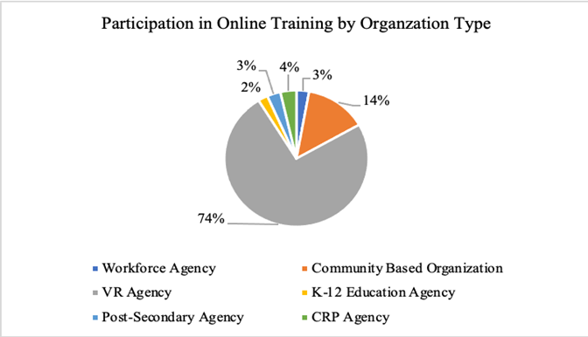
Participants in online training were asked to voluntarily indicate their job titles during the registration process. Notably, those employed in state VR agencies in various roles reported the highest participation rates. However, participation was also reported by those employed in roles important in serving and supporting VR consumers through community partner organizations (i.e., employment specialists, rehabilitation counselors (not otherwise specified), job coaches, and benefits specialists).
Furthermore, participants were asked to identify by the job title that most closely fit their current role. Thirty-seven percent (37%) reported working for VR in some capacity, with an additional 15% specifically identifying as Vocational Rehabilitation Counselors (VRC). Twenty percent (20%) identified as employment specialists, 15% as counselors, and less than 5% each as directors, managers, supervisors, job coaches, benefits specialists, case facilitators, or other occupational specialists.
Figure 18. Online Training Participants by Job Title
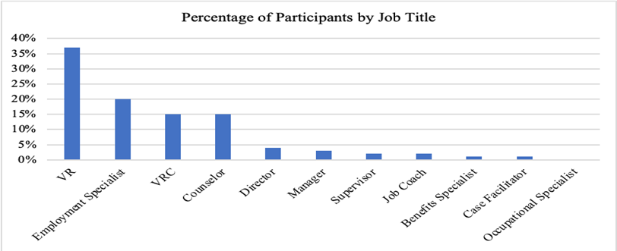
Participants in online training were asked to indicate which state or territory they worked in. The states of Georgia, Kentucky, Wisconsin, North Carolina, California, and New York reported the highest numbers of participants. However, individuals in all 50 states and the District of Columbia, plus five U.S. territories, engaged in the training opportunities.
Figure 19. Participation in Online Training by State or Territory (Representative Sample)
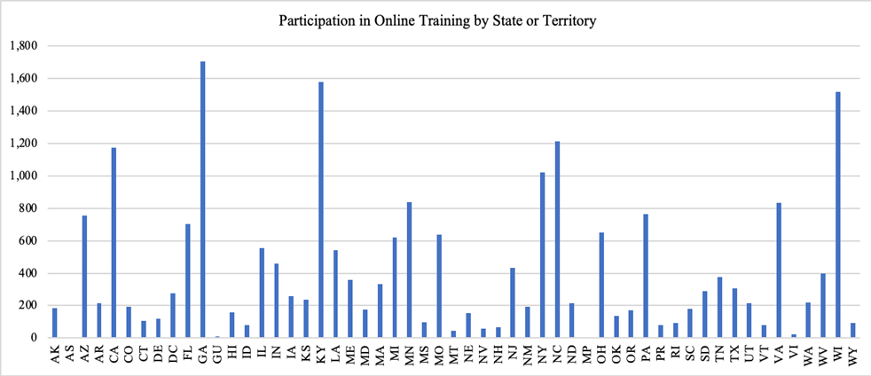

Project Measure 5.c. Number of participants engaged in Communities of Practice (CoP). Project E3 also had broad-based communities of practice (CoP) covering a variety of topical areas. The CoP was facilitated online and open to anyone interested in joining to connect, learn, and share resources. The framework for the CoP was built during the initial phases of the project. Once the project began actively disseminating information about the CoP in Year Three, participation rates increased rapidly, resulting in a total of 1,392 active members in Year Four, and 2,885 in Year 5 sustaining into the No Cost Extension period. The project averaged about 71 new members each month, representing VR personnel (about 36%), community service providers (about 25%), and other key stakeholders. The CoP served as an effective opportunity for VR personnel and community providers to connect, resources, and learn with and from each other. Topics discussed included serving individuals residing in rural and remote areas, disability and poverty, career development, employment research, and social security benefits and employment.

Figure 20. Number of Community of Practice (CoP) Participants Across Project Years
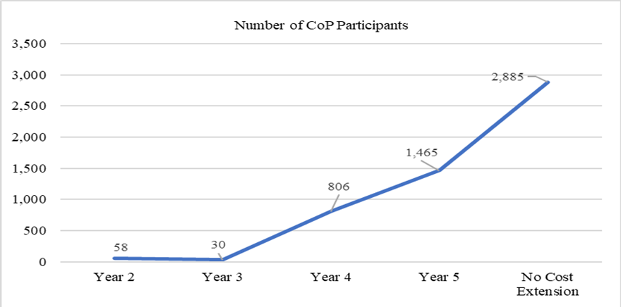

Table 3. CoP Member Self-Identified Roles
Role | # Of CoP Members | % of CoP Members
Community Service Provider | 721 | 25%
Executive Team Member | 64 | 2%
Interested Individual | 651 | 23%
Project Partner | 75 | 3%
VR Administrator | 176 | 6%
VR Practitioner | 1,157 | 40%
Role Not Identified* | 41 | 1%
Total | 2,885 | 100%
*Note: 1% of CoP members opted not to declare roles
Project Measure 5.d. Number of Sessions on Project Website as a Reach and Engagement Measure.
ProjectE3.com served as a state-of-the-art, comprehensive website disseminating information around issues related to poverty, disability, vocational rehabilitation, and employment. Topical areas on the website include generational poverty, health, homelessness, food insecurity, transportation, interpersonal and family issues, public benefit, financial empowerment, and other areas. All content was available for stakeholders to explore, use, and share in supporting state VR agency professionals and their community partners to help traditionally underserved individuals with disabilities from economically disadvantaged communities achieve employment and independent living goals. The site highlighted project activities, evidence-based strategies, leadership academy resources, best practices and research summaries, podcasts, webcasts, partner, and affiliate information, and more.
Profiles describing the targeted communities and the priority population in each state, including local unemployment and poverty indicators, population characteristics, and strategies to address barriers with contact information for the E3 partners in each community were available.
The website was actively updated through June 2021. The site was developed during the first year of the project, and content was actively uploaded throughout Year Two. By Year Four, the project began to see a substantial uptick in viewer sessions as aligned with strategic communications, the evolving CoP, and active increase in online training (webinar) participation (Figure 22). While a lower rate of website session viewing occurred during the No Cost Extension period, the site still experienced 22,547 session views which indicate considerable ongoing interest in the content made available. A total of 96,410 website viewing sessions were recorded throughout the project, a figure nearly doubling the projected target. This suggests that the topical content featured was relevant and timely in addressing content and resource needs in the field.

Figure 21. Number of Participant Website Sessions Across Project Years
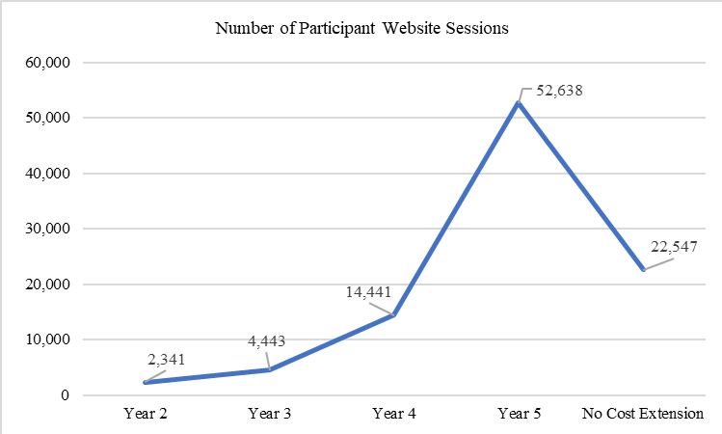
Project Measure 5.e. Number of social media (Facebook, Twitter) Views as a Reach and Engagement Measure
Knowledge translation through effective outreach and engagement was an important part of the project. Participation across the various forms of training and engagement increased each year. Specifically, the spikes in Twitter impressions were closely linked with the implementation of webcast information in Years Four and Five. Increased participation was noted in alignment with training focused on social security benefits and work incentives. A total of 173,247 social media views (146,782 Tweet Impressions and 26,465 Facebook Views) were noted during the project. The project team aimed for a reach of 160,000 views (40,000 views per year) but exceeded this goal by 8%. This suggests a strong interest in the content shared through social media as part of the project's strategic communication efforts.
Figure 22. Number of Social Media Views as a Project Engagement Measure
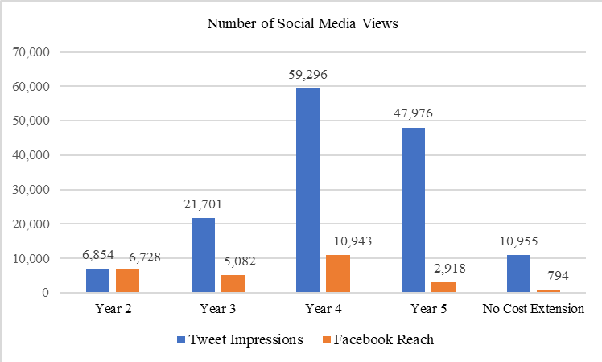
Project Measure 5.f. Number of Searchable Research Articles, Research Summaries, and Resource Articles Promoting Evidence-Based Practices.
The project website featured a keyword search component to allow users access to numerous topics linked to a database of research articles, research summaries, and resources.
The Resource Library, available through the project website, was searchable by keyword, by population served, and by the community, or strategy to help link the field to relevant resources and readings. New content was added regularly.
Research Summaries included at-a-glance plain-language research summaries intended to link busy professionals in the field with academic research into evidence-based practices. These materials were designed to enhance understanding of research in the field by topic by offering user-friendly information that could be applied to daily practice.
Resource Roundup provided current information on a variety of topics, including a link to the project's Counselor Toolkit, COVID-19 resources, and many other topics. Strategies to address barriers include information on evidence-based practices, such as job clubs, financial literacy training, motivational interviewing, customized employment, and more. Materials were organized by strategy and designed for application to daily rehabilitation counseling practice.
A total of 312 journal articles, 42 research summaries, and 413 resources articles were made available in the database. The team aimed to offer at least 600 publicly available searchable resources throughout the project timeframe and exceeded this by 28%, offering a total of 767 items.
Table 4. Overview of Searchable Project E3 Resources

Searchable Resource | Number
Journal Articles | 312
Research Summaries | 42
Resource Roundup Featuring Promising and Evidence- Based Content and Tools | 413

Sustainability and Systems Change
A focus on sustainability and systems change was present throughout the life of the initiative, but the focus shifted as project partners began to evaluate the impact on the communities served. Targeted technical assistance (TTA) was initially provided through training at national conferences for rehabilitation educators, vocational rehabilitation leaders, and broader audiences of rehabilitation and community-based practitioners. Examples included sessions at the National Council on Rehabilitation Education (NCRE), the Council of State Administrators of Vocational Rehabilitation (CSAVR), the National Rehabilitation Association (NRA), and the National Association of Benefits and Work Incentives Specialists (NABWIS). Additionally, project staff presented at state and local conferences and training events upon request.
As Project E3 advanced its work plan, efforts shifted from targeted national audiences into the exploration and development of key concepts and resources. TTA was provided in response to state- specific requests as well as activities addressing broader needs as identified by project leadership.
The Project E3 Leadership Academy, including state-specific sustainability plans, technical assistance targeted in Milwaukee, and capacity building around financial empowerment, highlight these efforts.

Project E3 Leadership Academy
To support longer-term efforts at the local and state levels, a Leadership Academy was held in New Orleans during September of 2019. VR personnel and staff members of community agencies across all 12 ITA states and the 24 targeted communities were invited to participate in the two-day event to gather to learn from each other and prepare individual "Sustainability Plans" to continue the work initiated through Project E3.
To complement and further enhance the work begun at the Leadership Academy, an additional Community of Practice (CoP) was established at the end of Year 4. This CoP was composed of key leadership in all 12 state ITA projects. The CoP met monthly to share information, continue implementing project change efforts, and promote the sustainability of those changes within their communities.
The following resources highlight key sustainability efforts across the ITA sites stemming from the Leadership Academy. Appendix X offers site profiles for each of the 12 participating states including populations served, targeted communities, and poverty rates, across the 12 participating states.
- The Story of Maxine Gretchokoff
- Civility Defined: Promoting Civility, Compassion, and Courage
- Self-Employment
- Transition Age Youth Who Are Dear or Hard of Hearing
- Project E3 Sustainability Plans
- Faith-Based Involvement and Reaching Transition Age Youth
- Development of an LGBTQ+ Repository
- Going Virtual Challenges, Accessibility, Communication Microaggressions, Social Media Sparks, State Sustainability Plans
- Community Academy
- Integrated Resource Teams (IRTs)
- Self-Employment
- E3 Grant: South Carolina - Working with diverse populations, partnering with local churches and faith communities, and developing a resource guide
- Expanding Employment Opportunities for Underserved Populations
- Client Engagement in a Virtual Environment
- Ethics and Self-Care & Quality Indicators of Customized Employment
- Financial Empowerment
- Introduction to Implicit Bias
- Intersectionality
- Constructive Discourse: How to Have Tough Yet Safe Conversations

Furthermore, as an output of the October 2020 Virtual Leadership 2.0 Conference, the following ITA states recorded videos highlighting their continuation and sustainability plans.
- California Continuation and Sustainability Plan Video
- Kentucky and Oregon Continuation and Sustainability Plan Video
- North Carolina Continuation and Sustainability Plan Video
- Louisiana Continuation and Sustainability Plan Video
- New Mexico Continuation and Sustainability Plan Video
- New Jersey Continuation and Sustainability Plan Video
- Virginia Continuation and Sustainability Plan Video

Understanding the Influences of Race, Disability, and Poverty on Employment in Milwaukee
In May 2019, the Wisconsin Division of Vocational Rehabilitation (DVR) connected with Project E3 through colleagues at the Workforce Innovation Technical Assistance Center (WINTAC). Wisconsin DVR expressed interest in gaining a better understanding of the employment service needs and perspectives of program participants residing in the Central City of Milwaukee. For many years, the VR program consistently reported lower engagement and outcomes in this geographic area noting a high percentage of concentrated and multigenerational poverty in the community.
Participants shared insight and perspectives into their experiences with DVR, their goals and aspirations for the future, and the challenges that poverty or lack of resources presents when seeking and engaging in employment. Primary participant perspectives included:
- the importance of effective counselor communication, responsiveness, and working alliance,
- concerns about staff turnover, delays in the VR process, and staff members lack of time and flexibility,
- the influence of race,
- challenges presented by poverty, and
- suggestions for improving VR services in this community.
The Project E3 team used the participants' perspectives and suggestions to develop a set of near-term and longer-term recommendations designed to help inform policy and systems decisions to positively impact programmatic outcomes. Following the issuance of the report, DVR leadership actively began implementing many of the near-term recommendations and established an internal protocol for reviewing all agency policies using trauma-informed approaches. The longer-term aim is to reduce VR staff turnover, improve culturally responsive service delivery to consumers, and improve employment outcomes for individuals with disabilities of color living in this low-income community.
A copy of the Milwaukee report, Understanding the Influences of Race, Disability, and Poverty on Employment, is available.

Financial Empowerment Capacity Building
In May 2017, members of the Project E3 team were selected to participate in a session hosted by the World Institute on Disability (WID) at Gallaudet University and provide input into the Consumer Financial Protection Bureau's (CFPB) new financial empowerment toolkit, Your Money, Your Goals, for individuals with disabilities. The Federal Deposit Insurance Corporation (FDIC) developed similar tools to enhance financial literacy, Money Smart and FDIC Money Smart and Youth Employment. Following the release of these resources, CSAVR led Project E3's efforts to build awareness and capacity for integrating financial empowerment into the VR process through specified TTA events.
The primary resources used to build awareness and capacity were:
- Your Money, Your Goals: A Financial Empowerment Toolkit Consumer Financial Protection Bureau
- FDIC Money Smart and Youth Employment
- Money Smart Program

The National Clearinghouse of Rehabilitation Training Materials (NCRTM)
Materials developed through Project E3 were submitted to the NCRTM and added to their online library. The aim is to facilitate and encourage ongoing access beyond the scope of the initiative, and all materials are accessible per Section 508 compliance standards. Project E3 webcasts are available via the project's YouTube channel.

Summary
In summary, Project E3 successfully met the established GPRA measures in nearly all areas. Given the long-standing challenges experienced by historically underserved HLGNA populations, coupled with the challenges presented by community poverty, modest gains should be interpreted as successful. Furthermore, the Covid-19 pandemic directly impacted VR participant employment, earnings, and programmatic operations during 2020 which influenced overall outcomes in specific areas.
Aggregate applications, eligibility determinations, IPEs, services under an IPE, employment outcomes, and employment rates for priority populations in the targeted communities improved proportionally relative to the priority population groups in the rest of their respective States.
Improvements were particularly noteworthy regarding IPE development and competitive integrated employment attainment after an IPE, in which individuals from priority groups in targeted communities achieved 11 and 9 percentage-point improvements, respectively, relative to their counterparts in the rest of their States.
Although these indicators declined by FY 2019, likely due to a significant degrees on the Orders of Selection adopted by VR agencies in most of the participating States and the disproportionate impact of the COVID-19 pandemic on the priority populations in the targeted communities, the declines were consistent with the statewide declines.
Moreover, even with these declines, HGLNAs in the TCs were proportionally improved at project’s end than at baseline in key performance measures.

Measure 1: Increase the participation in State VR programs of individuals with disabilities from low-income communities.
- The total number of HLGNA individuals applying to VR in targeted communities during the project was 5,243. This represents an increase of 943 applications during the project (see Figure 3). This finding is based on the number of applicants observed at baseline (2016; n=860) relative to the higher number of applications across subsequent years (2017 - 2020; x̅ =1,020/year) and includes drop off in applications in 2019 and 2020 due to the Covid-19 pandemic.
- The percentage of these applicants deemed eligible remained consistent at 99%.
- The percentage of eligible applicants with an Individualized Plan for Employment (IPE) increased by 38.6% from 2016 (n=268) to 2020 (n=438; see Figure 3).
Measure 2: Increase the number and percentage of individuals with disabilities from low-income communities that achieve competitive integrated employment (CIE).
- The number of individuals exiting the VR program with employment varied during the project period. A total of 544 HLGNA individuals exited with cases closed successfully in CIE between 2018-2020 compared with a total of 229 in 2017. Technically, the numbers decreased between 2019-2020, however the decrease is attributable to the Covid-19 pandemic and restrictions presented by Order of Selection (OOS) implementation.
- The percentage of individuals exiting the VR program with CIE after receiving VR services (Rehabilitation Rate) increased by 3% by the end of the project for a rate of 36.0%. However, additional gains may have been obscured or prevented due to the Covid-19 pandemic.
- The median weekly earnings of individuals achieving CIE decreased by between baseline and 2020 by $25. This data reflects business closures and layoffs during 2020 due to the Covid-19 pandemic. However, overall growth in employment in 2021 coupled with increasing wages are anticipated to increase the median weekly earnings.
Measure 3: Increase the support services provided by community agencies to individuals with disabilities from low-income communities who participate in the VR program.
- The number of community rehabilitation programs, community-based organizations, and other organizations providing direct support services as a result of the project's capacity-building, training, and TA activities increased by 121 throughout the project.
Measure 4: Increase coordinated VR program/community agency service delivery systems and strategies providing comprehensive supports to individuals with disabilities from low-income communities who participate in the VR program.
- The number of formal comprehensive support partnerships among VR agencies, community rehabilitation programs, community-based organizations, and others initiated through the project increased by 65 throughout the project.
- The number of organizations involved in partnerships initiated through the project increased by 368 throughout the project.

Challenges, Opportunities, Recommendations, and Conclusions
Throughout the project, awareness, and understanding of how a wide variety of factors such as psychosocial, daily stressors, lack of financial empowerment, and systems-level issues presented barriers and challenges for individuals with disabilities in the targeted communities. Examples of psychosocial issues identified include low expectations, societal attitudes towards disability, lack of soft skills, and a distrust of institutions, especially by individuals living in marginalized communities.
Additionally, living in poverty presents daily stressors including a lack of safe and reliable transportation, food insecurity, lack of affordable housing, lower educational attainment levels, and a lack of local employment opportunities. Financial factors, including the fear of losing access to public benefits if one pursues employment were present as well. A lack of experience working with money and saving, as well as a disconnect with formal banking and financial systems were present. And the lack of employment opportunities within communities, including recognizing that employers may not be engaged with the targeted community or the population. Furthermore, broad systems- level issues, including a lack of services and funding coordination, including systems of public support, are often difficult to navigate, with VR and community-based staff lacking the capacity to serve low-income populations with complex needs.
Individually, these issues present significant personal and environmental challenges for individuals with disabilities seeking to engage in competitive integrated employment. Collectively, the compounding nature of the issues can be overwhelming and require thoughtful, strategic, investment in meaningful systems change efforts building on what was learned through Project E3.
Strong collaboration and coordination among federal, state, and local partners are critical.
Furthermore, the use of contemporary promising and evidence-based resources across disciplines, similar to the approach initiated through Project E3, will drive innovation, enhance wrap-around approaches to service delivery, and support the improvement of quality employment outcomes for HLGNA populations residing in low-income communities.
The challenges will not be resolved overnight and significant improvements in quality employment outcomes for these populations will take time. However, improving the VR system to better serve historically underserved and marginalized individuals with disabilities living in low-income communities has the potential to improve health and employment outcomes and individual's lives, and positively impact related disability support systems (i.e., Social Security and Medicaid among others) through longer-term cost savings.

Challenges
Specific challenges noted by state VR agencies and project partners are as follows:
Staffing Shortages Creating Lack of Capacity to Fully Engage. While several states initially engaged with Project E3 staff to develop training and technical assistance plans, they weren't always able to move these efforts forward as intended. As an example, state VR leadership from the New Jersey-General VR program shared that while they were eager to participate, they lacked the staffing necessary in two key offices to fully engage with Project E3 and implement all planned change initiatives. At one point, the agency was contemplating withdrawing from the project due to significant staff shortages as well as navigating a transition to a new administration. However, through the support of the community partners on their E3 Advisory Council, they were able to successfully complete the project.
Covid-19 Pandemic. Due to the impact of mitigation measures necessary to curb the spread of Covid-19, unemployment during year five of the project skyrocketed to levels not seen since the Great Depression. State governments responded to the overwhelming demands to address this high level of unemployment through the provision of unemployment benefits and other supports offered at the state level. This created a need to shift state government resources and personnel to address those needs, which in many states also involved personnel from the state VR agency being reassigned to process unemployment insurance claims. In addition, many public agencies enacted stay-at-home orders due to health and safety concerns, which necessitated the closure of state offices. State VR agencies were required to quickly adapt their programs to provide services remotely via telephone or the Internet and establish policies for managing a workforce that was largely working from home. This level of the shift was unprecedented in modern times.
Furthermore, the Covid-19 pandemic disproportionately impacted individuals within the HLGNA groups, particularly those living in low-income communities. While many challenges related to disparities in transportation, safety, and disproportionate representation in front-line service jobs in these communities preempted the pandemic, the issues were exacerbated by serious health and safety concerns presented by the virus.
Order of Selection (OOS). Throughout the project, there was an increasing trend for state agencies to close categories under their Order of Selection. Program leadership utilizes this mechanism to manage resources for current participants in balance with incoming applicants to the program. As of July of 2019 (year four of the project), eight of the 14 state VR agencies receiving Intensive Technical Assistance (ITA) from Project E3 had closed categories under their OOS plan. As of August 2021, 10 of the 14 programs had implemented OOS, but the number of open categories had shifted. Interestingly, while OOS created category closures and delays in VR engagement in service delivery midway through the project and more states moved in OOS implementation, categories opened during the pandemic which theoretically meant that VR had the capacity to serve more consumers. However, as noted earlier, health and safety concerns regarding Covid-19 reasonably explain the overall decrease in VR applications and the number of individuals seeking employment during this period.
Table 5. ITA States in Order of Selection PY2019 and PY2021
State VR Agency in OOS | # Categories Open/ Total Categories  PY 2019 | # Categories Open/ Total Categories  PY 2021
California-Combined | 2/3 | 3/3
Illinois-Combined | 3/4 | 3/4
Kentucky-Combined | 2/4 | 4/4
Louisiana-Combined | 4/5 | 4/5
Montana-Combined | 0/3 | 1/3
New Hampshire- Combined | 1/3 | 3/3
New Jersey-General | - | 3/3
New Mexico- Combined | 1/3 | 1/3
Minnesota-General | - | 3/4
Virginia-General | 0/3 | 3/3

It is reasonable to assume that if individuals opt not to access VR services in their community, or are simply unaware of the program, the unemployment rates among HGLNA populations within low- income communities will continue and perhaps increase. Therefore, the efforts of Project E3 to develop coordinated service strategies with a variety of community partners provide an opportunity to help individuals better connect with VR and begin engaging in the process to prepare individuals for future employment.
Change in Leadership and Staff at VR Agencies. Changes in leadership and counselors at state VR agencies continued to present challenges throughout the project. Changes in leadership, both within VR as well as state-level changes in various bureaucratic levels, impacted the ability of states to implement technical assistance efforts and sustain initiatives. Project E3 partners actively engaged with new leadership as changes occurred to educate on the benefits of participation in Project
E3 initiatives. This provided an opportunity for the project to recruit new "champions" within VR agencies to promote the goals and objectives of the program. While successful and welcome at some sites, changes in leadership presented challenges at others, and progress in fully implementing the ITA plans was observed.
High turnover rates in front-line counseling staff and related VR personnel were also challenging across several of the sites. As an example, leadership in Illinois noted the need to start hiring individuals with little to no background in disability to meet staffing needs. This presented challenges for the agency in simply training new staff in disability "basics". The Project E3 staff are concerned that if this pattern persists across VR programs, significant training and technical assistance will be needed to bring staff knowledge and capacity up to acceptable levels to effectively support consumers with disabilities in achieving employment outcomes.
Lack of Awareness of the Scope of Services Offered through VR Programs. It was clear that a substantial number of individuals with disabilities residing in low-income communities were unaware of their likely eligibility to receive a full array of employment and employment-focused services through their state VR agencies. The need to "demystify" and actively promote VR as an effective resource in helping individuals with disabilities achieve their employment and career goals in low-income communities, as elsewhere, continues.
Transportation. The systemic lack of reliable, accessible, and safe transportation remains a significant barrier to employment in many of the communities served under Project E3.
Poverty-Based and Rural Issues. Many low-income individuals and families with disabilities are dependent on Supplemental Security Income (SSI) benefits to make ends meet. This often includes the SSI benefit received by children under age 18 in these households. Furthermore, there are limited job opportunities in rural communities, and many of those jobs are not part of a broader career pathway or meet the employment quality indicators including living wages and the option to access affordable private health insurance.
Many rural communities continue to be "information have-nots", as there are often poor cellular and internet services available. This lack of opportunity to connect with the information superhighway is a major disadvantage in a fast-changing labor market, which requires constant updating of skills and abilities to remain competitive. Additionally, affordable child-care remains elusive for many low-income families, including those with disabilities seeking to enter or re-enter the workforce.

Opportunities
Several opportunities to support ongoing improvement in VR services emerged throughout the project. First, the high engagement rates in online, web-based training for VR professionals and stakeholders accelerated throughout the project. Participants rated the online opportunities highly and this modality presents a cost-effective format for delivering high-quality training to a broad and diverse audience of stakeholders into the future.
Training and technical assistance to support the development of Integrated Resource Teams (IRT) demonstrated effectiveness in the early phases of implementation. This innovative model offers opportunities to connect system and community stakeholders and design longer-term employment supports for individuals with disabilities by leveraging existing resources across programs. Project E3 integrated this model into select ITA sites and preliminary data suggests that serious consideration be given to replicating it elsewhere.
Additionally, the importance and impact of developing and nurturing productive relationships between VR, Community-Based Organizations (CBO), and Community-Rehabilitation Programs (CRP) were clear through Project E3. Individually, these programs serve individuals with disabilities. Collectively and in partnership, these programs can effectively leverage resources and collaborate in serving individuals with disabilities with complex needs residing in low-income communities.
Furthermore, the opportunity to encourage CBOs to connect and foster relationships among themselves inherently and positively influences individuals with disabilities as many can serve as conduits to encourage viable applications to the public VR program.

Recommendations
The following recommendations are based on formative and summative evaluation efforts, the perspective of VR program personnel participating in the project, and input provided by the project partners. The aim is to offer information to help guide future decision-making regarding ongoing program needs, priorities, and investment of federal resources.

Recommendation One: Further Invest in Vocational Rehabilitation Systems Change Initiatives Focusing on Disability, Poverty, and Employment
It is recommended that RSA further invest in capacity building within state VR programs to address the needs of individuals with disabilities experiencing poverty.
While Project E3 provided important resources to begin exploring and addressing the intersection of disability and poverty within the context of vocational rehabilitation programs, it represents a starting point and an ongoing need to build upon this work is clear. The issues impacting historically underserved and marginalized populations of individuals with disabilities are deep and complex and cannot be solved within one grant cycle. However, as learned through this center, state VR programs and community stakeholders are open to engaging in training and technical assistance to better understand and improve services to these populations.

Recommendation Two: Enhance Cultural Competence and Responsiveness Within VR
It is recommended that RSA further invest in improving state VR personnel competence and responsiveness regarding cultural awareness, competence, and responsiveness in working with individuals from diverse racial, ethnic, gender, and socioeconomic backgrounds.
The inequities and challenges experienced by individuals with disabilities from diverse racial, ethnic, gender, and socioeconomic populations must be better understood by personnel working in the state VR programs. Increased understanding of the lived experience, daily stressors, and subsequent trauma faced by many can help to modernize the VR program and better address the needs of program applicants and participants.

Recommendation Three: Continue Improving Collaboration Between State VR Programs and Local Community Rehabilitation Providers (CRP)
It is recommended that RSA continue to encourage and support improved collaboration between state VR programs and their state and local CRP partners.
As learned through Project E3, establishing healthy, collaborative partnerships between state VR programs and community rehabilitation programs is essential in promoting positive employment outcomes. Many VR programs rely on a cadre of community providers to effectively serve consumers of the VR program. Importantly, approaching these relationships as partnerships, rather than as "vendors" which assumes a hierarchy, supports positive engagement and collaboration in serving consumers of the program. In many communities, the public VR program simply cannot effectively serve all consumers without working in partnership with community-based providers.

Recommendation Four: Critical Need to Address High VR Turnover Rates in Targeted Communities
It is recommended that RSA actively provide guidance and support to state VR programs in hiring and retaining qualified personnel to effectively meet the needs of consumers with disabilities living in low-income communities.
Across ITA sites, high turnover rates among counselors and front-line staff presented ongoing challenges. While this was not unique to the targeted communities, the attrition rate appeared to be higher in these areas. State leadership faced continuous training needs in hiring, onboarding, and establishing basic competencies among staff in serving individuals with disabilities. Those with access to hiring qualified rehabilitation professionals (e.g., Certified Rehabilitation Counselors) reported lower initial training needs and higher competency which is important to note. However, supporting all VR staff serving low- income consumers experiencing an array of complex and stressful life issues is paramount. Introducing trauma-informed approaches, including policies and key staff supports, is recommended. Additionally, guidance from RSA regarding competitive wages commensurate with established educational and knowledge competencies in serving individuals with disabilities is recommended. VR leaders noted significant challenges in trying to retain qualified staff when competing with the wages offered by other agencies and the private sector.

Recommendation Five: Identify Contemporary and Proactive Methods for Engaging VR Consumers on Order of Selection (OOS) Wait Lists
It is recommended that RSA to actively engage VR agencies and community partners in discussion to identify innovative options for engaging individuals on OOS waitlists to promote early engagement in employment-seeking options.
While the number of state VR agencies opening their waitlists increased during the pandemic, it is recommended that state VR agencies, with the support of RSA, engage in active discussion regarding the sharing of emerging and promising practices to engage individuals on waitlists for services. Research indicates that rapid-engagement strategies support stronger participation and outcomes in the VR process. Those placed on waitlists for services through the OOS process can benefit from other services and support available through community-based partners during this period.

Recommendation Six: Further Funding Recommended to Replicate Promising and Evidence- Based Practices in Low-Income Communities
It is recommended that RSA endorses further funding to replicate efforts initiated through Project E3 and expand opportunities for community collaboration, employment, and financial mobility for individuals with disabilities in low-income communities.
Further funding is recommended to support replication and expanded implementation of evidence-based practices that enhance engagement and employment outcomes of individuals from the targeted populations and communities in meaningful employment through the public VR program. While Project E3 identified and implemented contemporary practices in the ITA sites, ongoing support is necessary to sustain these efforts as well as expand and replicate them in comparable communities. The need continues to be great and ongoing efforts to extend and expand these initiatives are encouraged.

Conclusion
State VR agencies, through the assistance of Project E3, expanded their outreach efforts to community-based organizations and developed effective collaborative partnerships. Building and maintaining these relationships has tremendous potential to positively impact individuals with disabilities living in economically disadvantaged communities. In the various project sites, community resources were critical in providing necessary wrap-around services to help reduce the impact of the barriers to employment often resulting from living in areas of high poverty.
While the primary concerns limiting service provision and economic opportunities for people with disabilities (i.e., transportation, lack of high-quality jobs, pervasive poverty stressors, lack of self- employment, and lack of employer networks) are still very much present, Project E3 demonstrated that intentional planning and concentrated investment in capacity building within VR and low- income communities can positively influence attitudes, systems, and outcomes for individuals with disabilities.

Appendix

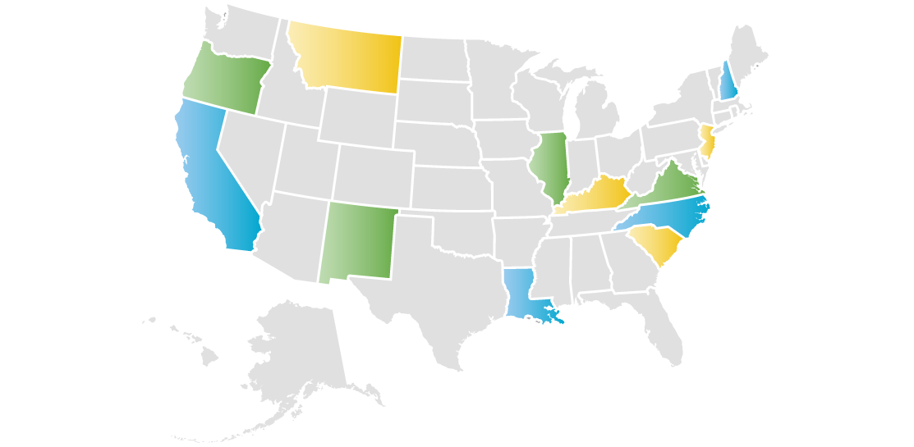

California

Summary of State Project
California is the most populous state in the United States. It is regarded as a global trendsetter in both popular culture and politics, and is the origin of the film industry, the hippie counterculture, and the Internet and personal computer. Fifty-eight percent of the state's economy is centered on finance, government, real estate services, technology, and professional, scientific, and technical business services. It has the 6th largest economy in the world and one of the highest disability rates in the nation.
Agriculture is the primary industry in California’s Central Valley. Primary sources of population growth in this region are people migrating from the San Francisco Bay Area seeking lower housing costs, as well as immigration from other countries. Apart from Hawaii, California has the highest cost of living in the United States. While the state has areas of high wealth, it also experiences concentrated pockets of poverty.

Project E3 Partner
University of Illinois-Urbana Champaign (UIUC)

Targeted Communities
The state-federal vocational rehabilitation system in California faced many challenges as it strove to serve people with significant disabilities and promote competitive integrated employment. Project E3 provided intensive technical assistance to two cities in California’s Central Valley: Southeast Fresno (Region 1) and North Central Bakersfield (Region 2).

California State Map Highlighting ITA Targeted Communities
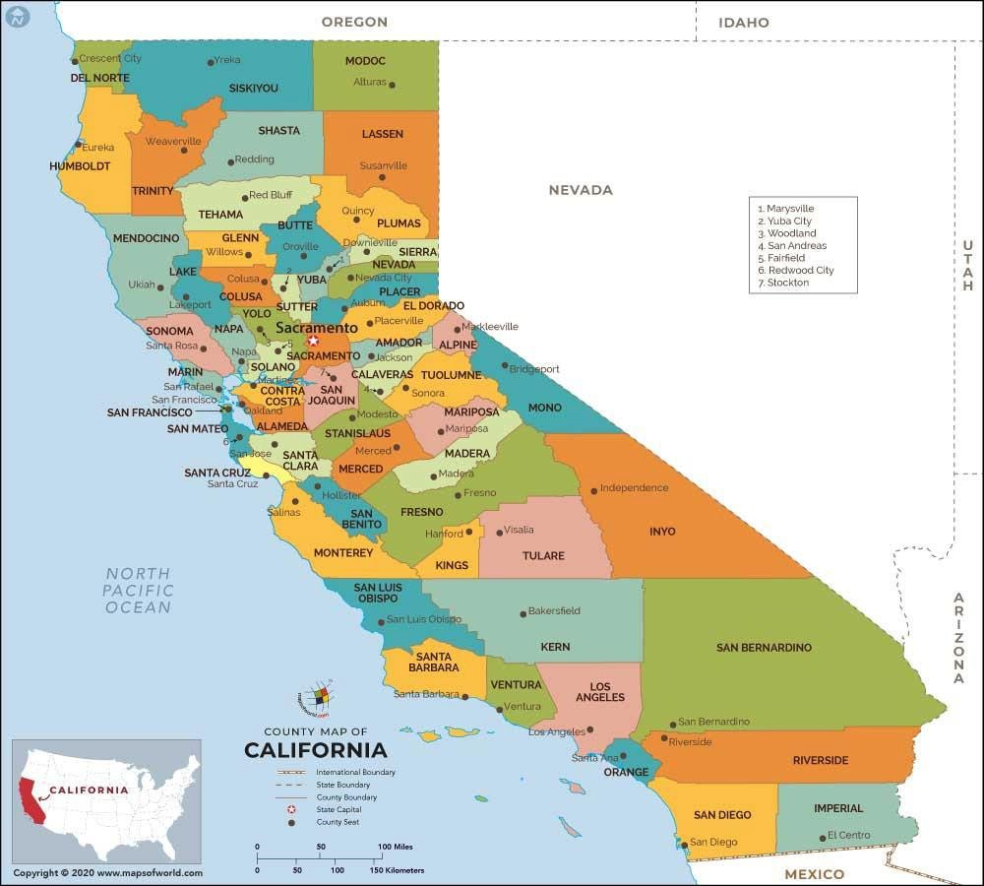

High Leverage Groups of National Applicability (HLGNA)
Within the targeted communities, Project E3 focused on improving vocational rehabilitation service outcomes for (a) Hispanic young adults aged 18-30, and (b) Asian young adults aged 18-30. These populations were further characterized as:
- Consumers receiving federal financial assistance (TANF)
- Culturally diverse populations
- High school dropouts and functionally illiterate consumers
- Persons with multiple disabilities
- SSI and SSDI recipients

Primary Challenges
Research suggested that both targeted populations were at increased risk for experiencing trauma. The effects of trauma can reduce participation in employment-related activities and affect vocational rehabilitation service outcomes. Furthermore, there was a need to increase awareness of VR services and strengthen the relationship between community-based organizations and VR.
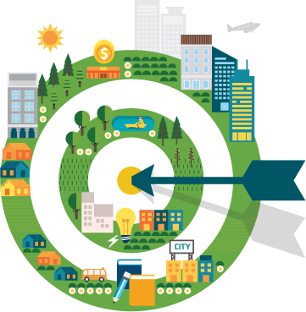

Specific Goal(s) for This Project
Within 3 years, attain the same rate of vocational rehabilitation applications and successful employment for 18- to 30- year-old Hispanic and Asian applicants as the state-wide average.

Key Strategies to Address Barriers
The key strategies developed and implemented to address the targeted populations' challenges and barriers to employment:
Outreach: Brochures about VR were developed and distributed to community-based organizations serving these populations to enhance awareness of the VR program.
VR Screening Tool: Developed and piloted a screening tool for use by community-based organizations to better identify individuals who may be eligible for VR services.
Benefits Counseling: Provided information on Social Security program rules and how employment impacts benefits. The goal was to help people make informed choices about employment.
Career Exploration Group: Discussed employer expectations, learned job and social skills, and explored postsecondary education programs. The goal was to increase participants’ ability to explore and access careers. The group was ultimately peer-led.
Employability Skills Training: Increased participants' ability to work with others and function socially. Taught participants how to adjust to workplace expectations, including written and unwritten rules and social norms.
Financial Literacy Training: Supported people to develop skills and knowledge about personal money management and helped them develop a plan for their financial future.
Trauma Informed Care: Many people experience trauma during their lifetimes. People who have experienced repeated, chronic, or multiple traumas are more likely to experience substance abuse, mental illness, and health problems. Using a trauma-informed approach when working with people who have experienced trauma can make the difference in developing positive relationships and supporting them to reach their work and life goals.
English as a Second Language Training: Connected non-native speakers with language learning opportunities in the community.

Site Partner Reflections
California vocational rehabilitation stakeholders did not participate in a final interview about services for this programmatic report. However, they did create a short video for the Leadership Academy that provided some helpful contextual information to highlight the impact of Project E3 in the state.
California’s first HLGNA included young adults (18-30) who receive public assistance and are Hispanic with a disability or chronic illness. California’s second HLGNA included Young adults (18-30) who receive public assistance and are Hmong with depression and PTSD. In this video, accomplishments and sustainability efforts were highlighted as follows.

Accomplishments
California stakeholders were able to accomplish the following throughout the course of Project E3:

Enhanced Community Connections/Outreach
Appeared on local community radio show (Hmong Radio Station) to target unserved and underserved populations which (a) led to an increased number of referrals for Hmong individuals and (b) helped educate and encourage community members to seek out resources.
From the video: “We were able to get connected with a local community radio station to focus on the Hmong population, which is an underserved and unserved population in our area and because of this we were able to increase our number of referrals for Hmong individuals”.
Created community-focused marketing materials to establish a more unified way of providing services to unserved and underserved populations
From the video: “The marketing materials allowed for us to make connections which resulted in resources and trainings and some local trainings which were fundamental and provided.”

Increased Staff Training in motivational interviewing, trauma-informed care, and money management
From the video: “Some trainings that were provided in the San Joaquin Valley district in California were motivational interviewing, trauma-informed training and money management” and the “trainings ensured that our staff and community partners had the tools and resources that they needed”.

Sustainability
In terms of sustainability, California administrators report the following steps to ensure the sustainability of their efforts:

Presentation to Executive Leadership for buy in.
From the video: “We want to be able to provide them with a presentation of economic project and the services we provide and the outcomes in order to get some buy-in”.

Dedicated staff person for RTI
From the video: “We have already been able to acquire a dedicated person for our IRT team, and we hope to be building an IRT team level around that individual”.

Continuing the established work group created as a part of Project E3 to expand pilot initiative statewide
From the video: “We also have a workgroup that we've established to expand the E3 pilots best practices statewide”.

Expanding IRT training
From the video: “...we've also recognized that we need to provide some training. We would like to expand as well on the IRT training for our current staff, and we are going to be dedicating some training funds to be able to provide that training”.

Gathering demographic data and implementing data driven practices
From the video: “We're also developing a demographic data project because we understand from the Project E3 that we really have to be data-driven in order to develop good practices, we need to know who our community is, we need to know who the people with her serving are and most importantly and the people with her not serving, and we hope that by understanding our local communities we can better build our program to meet their needs”.

Developing additional local advisory boards
From the video: “Another practice that really helped us through the E3 project is the local advisory board we're hoping to replicate that. We're already starting our second local advisory board in the southern part of our district, but we are also going to introduce it as part of the statewide best practices from E3 and hope to be able to use that as a model concept for all the Department of Rehabilitation regions”.

Securing funding for ongoing training in E3 project topics
From the video: “We are looking at …ways of securing funding for training. We have some potential of being able to continue providing training in the motivational counseling, the trauma-informed and the money management but also in being able to train additional staff on the integrated resource team model”.

Sustainability, Tools, and Resources
University of Illinois Urbana-Champaign Trauma Training Series
- Week One: Overview of Trauma Types, Trauma Rates, and Trauma Informed
- Week Two: Assessments, Screening, and Communication Strategies

- Week 3: Populations At Risk; Risk Factors for Maltreatment
- Week 4: Lasting Impacts of Chronic, Toxic Trauma
- Week 5: Understanding Resilience and Practicing Wellness
- Week 6: Evidence Based Trauma Interventions and Prevention Models

Illinois

Summary of State Project
Illinois is known as the “Prairie State”, as it was once covered with prairie grasses. Today, there is a combination of small industrial cities, agriculture, and natural resources like coal, timber, and petroleum. Illinois is also a major transportation hub connecting global ports from the Great Lakes and the Mississippi River.
Illinois is primarily divided into three sections. Northern Illinois is dominated by the city of Chicago and its suburbs. This area is heavily populated and industrialized. Central Illinois is mainly prairie and made up of small towns and medium cities. Agriculture and manufacturing centers are prominent. Southern Illinois has a warmer winter climate good for different varieties of crops, more rugged terrain, and small oil and coal mining operations.
The cultural diversity of Illinois can influence career participation and disability identification due to cultural backgrounds, language barriers, education levels, and lack of exposure to different types of work.

Project E3 Partner
University of Illinois-Urbana Champaign (UIUC)

Targeted Communities
The state-federal vocational rehabilitation system in Illinois faced many challenges as it strove to serve people with significant disabilities and promote competitive integrated employment. Project E3 provided intensive technical assistance to two regions in the northeastern and northern parts of the state: Cook County, including West and South Chicago (Region 1), and Winnebago County, focusing on the City of Rockford (Region 2).

Illinois State Map Highlighting ITA Targeted Communities
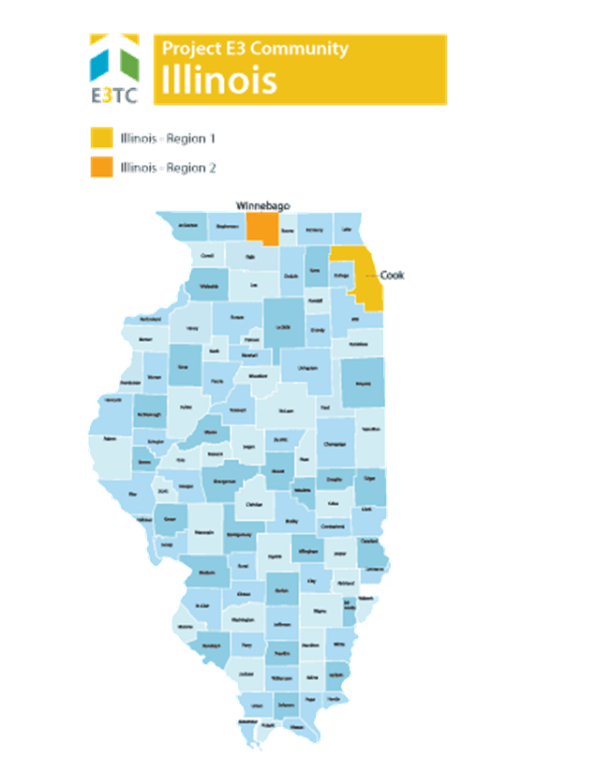

High Leverage Groups of National Applicability (HLGNA)
Illinois’s focus populations included (a) young adults aged 18-25 who were formerly incarcerated as a juvenile or young adult who have a residual psychiatric condition, cognitive impairment, or combination of both; and (b) individuals aging out of foster care between the ages of 18-25 who have a residual psychiatric condition, cognitive impairment, or combination of both. These populations were further characterized as:
- Adjudicated adults and youth
- Consumers receiving federal financial assistance through TANF
- Culturally diverse populations
- High school dropouts and functionally illiterate consumers
- Persons with multiple disabilities
- SSI and SSDI recipients
- Youth in foster care

Primary Challenges
The combination of the challenges above and other factors created significant barriers for persons with disabilities living in Illinois including (a) the ability to get and keep competitive, integrated employment; (b) employers’ lack of awareness of the benefits in hiring individuals within the targeted population; (c) employers’ and counselors’ lack of multicultural awareness; (d) concerns over loss of benefits; (e) awareness of supportive local resources including housing, family, medical, and legal services; (f) lack of role models and social support networks; (g) limited transportation due to financial restrictions; and (h) residual legal issues.

Specific Goal(s) for This Project
Project E3 provided Illinois’ state Vocational Rehabilitation agencies and their partners with the skills and competencies needed to effectively and efficiently address barriers to competitive integrated employment and community integration encountered by persons with disabilities in these regions.
The specific goals included:
- Increase the number of vocational rehabilitation applicants and number of people found eligible for service
- Increase the percentage of eligible individuals who develop Individualized Plans for Employment with their rehabilitation counselors
- Increase the percentage of individuals with Individualized Plans for Employments who obtain and retain integrated, competitive employment
The team leveraged promising practices, knowledge, and experience gained from this project to expand employment opportunities for individuals with disabilities from underserved and economically disadvantaged populations throughout Illinois and across the United States.

Key Strategies to Address Barriers
The key strategies developed and implemented to address the targeted populations' challenges and barriers to employment:
Community-Based Participatory Research (CBPR): To understand a community’s issues and concerns, one needs data and information both supplied by common data sources and interpreted by the community to better understand their issues and possible solutions to those issues. CBPR’s methodology is predicated on deep and extensive community involvement in the identification of issues and concerns and in the resolution of those issues and concerns.
Community Outreach and Orientation: The goal of community outreach and orientation was to increase referrals for vocational rehabilitation services from community-based organizations and applications from people with disabilities. To achieve this goal, the team worked to develop relationships within local communities and build capacity for outreach and knowledge about the hiring people with disabilities.
Evidence-Based Practice Training: The Illinois Department of Rehabilitation Services has contracted with the University of Illinois to continue E3 related programming for the next 5 years. The focus of the training will be VR counselors. The goal is to develop a series of training and other capacity building activities for the state that will be implemented over multiple years.
The Illinois Brief Screener: This evidence-based screener was developed and is available for use by direct care staff at Community Based Organizations in Illinois as a tool for assessing whether individuals may be a good fit for VR services.
Customized Employment: The project developed and distributed specialized Customized Employment Manuals within the Illinois Vocational Rehabilitation program. These tools serve as resources in the training of Community Based Organizations, Vocational Rehabilitation and other stakeholders in customized employment.

Site Partner Reflections
Site partner reflections for the state of Illinois included a discussion about community connections, trainings, barriers, and sustainability. It is important to note, due to several staff transitions, particularly those associated with Project E3, partner reflections were limited to their time involved towards the end of the project.

Community Connections
Attending joint Project E3 sponsored trainings with community-based organizations helped to facilitate new connections. As an example referenced by one staff member, “I actually was sitting next to two of the people from the CBOs was the foster care and customized employment for the youth, and we were doing a lot of talking about how our services, how we interact and, you know, giving them more information on who they can call if they’re having issues and so on and so forth, so they got to meet a nice-sized group of counselors there, plus management was there, but, if I’m not mistaken, and it was, that was very beneficial.”

Trainings
Administrators and staff on the call briefly mentioned attending trainings associated with Project E3 including the customized employment training for transition-aged youth, the foster care training provided by the Virginia vocational rehabilitation group, and the leadership academy. They did not expound on the trainings other than the ability to connect with community-based organizations due to joint training efforts that facilitated the community connections described previously.

Barriers
Barriers described in the close-out interview included lack of knowledge, the stigma and challenges related to incarceration status, need to strengthen connections with key community-based organizations, “heavy workload” of counselors, competing with community-based organizations, and the need for more training for both counselors and supervisors. Specific quotes to contextualize these specific barriers follow:
Lack of knowledge: “the barriers that we run into with those populations would be, I’m, the lack of knowledge from our VR staff itself, from the counselors, needing more training for them”
Incarceration status: “how do we help them to get, and also employers who will hire them, especially those who are incarcerated when they come out, employers who will hire them and whether or not while the person was incarcerated did they take the opportunity to take advantage of any rehabilitative services that were provided, like completing their GED, getting an associate’s degree, whatever kind of training that would allow them to come out to a trade, and the ones who did, they mostly went into construction, more than anything”
Need to strengthen connections with key community-based organizations: “One of the community organizations that we work with is the Safer Foundation, and our tie with them I don’t think is as strong as it needs to be. I don’t think that we are reaching each other like that needs to be”.
Heavy workload: “Heavy workload prohibits ability to attend trainings, including E3: I started joining in on the trainings when I could, which wasn’t often because our workload is real heavy here, and, but I saw how beneficial those trainings would have been if we would have been able to include more people in them”.
Competing with community-based organizations: “Also we’re competing with our community partners because of the fact that they have a contract with us, they’re trying to get customers to build, to fill their contract, which also could delay the timeframe in which the customer is actually working with us directly, you know, and that’s what’s happening with the STEP transition cases. But I think that’s what I understand from what you’re saying, Pam, in regards to that, but I don’t remember an actual form. And I may have seen it and didn’t know that that’s exactly what it was. Yeah, because there are a number of our community partners who have been working, who have been doing the actual same job duties that our counselors are supposed to be doing, which is a weakness on our part because the counselors rely on them to work with a particular population of our customers because of their weakness. And so that’s something we do need to pay attention to”.
Need for more training for both counselors and supervisors: “And WIOA has changed things because employers no longer have an option to say, oh, you have a disability, we’re not hiring you. You know, they are expected to hire people and prepare them, train them for work, and we’re expected to have our counselors to prepare them to work with them, how to do it. So the training piece, yeah, it is important, but the thing is…that it’s not just our counselors who need the training. It’s the supervisors who need the training also, and since our supervisors for the most part, at least 80% of our supervisors are promoted from the counselor role, so what they don’t know they’re taking into the role of supervisor, and if people are not doing it the way they learned how to do it or how they were used to doing it, it then makes the supervision ineffective”.

Sustainability
A discussion of sustainability efforts included focusing on maintaining and strengthening connections with community-based organizations and participating in additional training opportunities to improve services.
Maintaining and strengthening connections with community-based organizations: “we’re doing things in a different way remotely and we have to continue including the organizations in that will help us help our customers”
Additional training opportunities: “I know coming up soon…that the University of Illinois, Dr. Strauser’s group.. is going to provide us with… five years of training”.

Sustainability, Tools, and Resources
University of Illinois Urbana-Champaign Trauma Training Series
- Illinois Brief Screener
- Customized Employment Handbook for Serving Youth with Disabilities in Foster Care: A Handbook for Rehabilitation Counselors and Community Rehabilitation Providers
- Customized Employment Handbook for Previously Incarcerated Individuals with Disabilities: A Handbook for Rehabilitation Counselors and Community Rehabilitation Providers

Kentucky

Summary of State Project
Kentucky is known as the "Bluegrass State", a nickname based on the blue grass found in its many areas of rich, fertile soil. It offers diverse environments and abundant resources, and is known for horse racing, bourbon distilleries, coal mining, tobacco, and bluegrass music, among other things.
Kentucky is a primarily rural state, incorporating 54 Appalachian counties, and characterized by a high poverty rate relative to other U.S. states. The geographic isolation of Kentucky’s rural communities poses significant challenges for persons with disabilities in achieving competitive, integrated, and lasting employment, and community participation and integration.
The rural nature of Kentucky and the centralization of employment opportunities in urban areas create significant transportation and access barriers to employment opportunities.

Project E3 Partner
University of Kentucky-Lexington

Targeted Communities
The targeted communities in Kentucky were the geographically distinct regions of Wayne and Rockcastle counties (Region 1), and Jackson, Lee, and Breathnitt counties (Region 2).

Kentucky State Map Highlighting ITA Targeted Communities
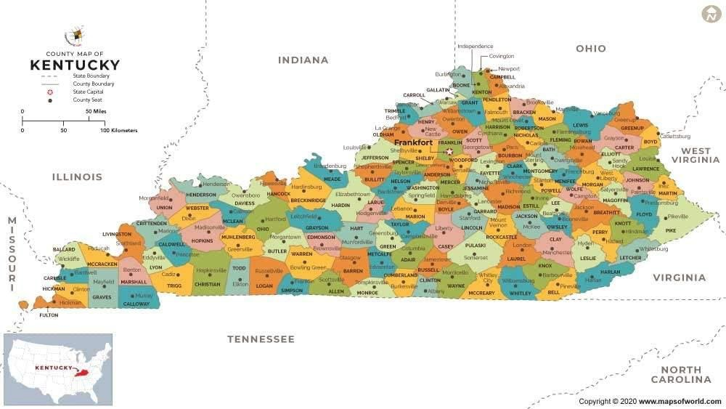

High Leverage Groups of National Applicability (HLGNA)
Kentucky’s focus populations included residents of economically disadvantaged rural and remote communities who (a) are students or transition-aged youth (aged 16-24) with diagnoses of commonly identified developmental disabilities and/or with specific sensory impairments seeking vocational rehabilitation rather than sheltered employment; and (b) individuals with mental health diagnoses for whom transitional employment is no longer an option under the Workforce Innovation and Opportunity Act (WIOA). These populations were further characterized as:
- Residents of rural and remote communities
- Subminimum wage employees
- Persons with multiple disabilities

Primary Challenges
The combination of the challenges above and other factors created significant barriers for persons with disabilities living in Kentucky, including access to and opportunities for residents of rural and remote communities, employees with subminimum wages, and persons with multiple disabilities.

Specific Goal(s) for This Project
The goal was to improve skills and competencies within Kentucky’s state Vocational Rehabilitation agency and their partners to effectively and efficiently address consumer barriers including limited transportation, limited employment opportunities in rural areas, inadequate outreach to potential consumers, lack of understanding of federal benefits and work incentives, limited work skills and understanding of employer expectations, limited soft skills, and limited work experience encountered by persons with disabilities in these regions. The team leveraged promising practices, knowledge, and experience to expand employment opportunities for individuals with disabilities from underserved and economically disadvantaged populations throughout Kentucky and across the United States.

Key Strategies to Address Barriers
The key strategies developed and implemented to address the targeted populations' challenges and barriers to employment:
Community-Based Participatory Research (CBPR): To understand a community’s issues and concerns, one needs data and information both supplied by common data sources and interpreted by the community to better understand their issues and possible solutions to those issues. CBPR’s methodology is predicated on deep and extensive community involvement in the identification of issues and concerns and in the resolution of those issues and concerns.
Community Outreach and Orientation: The goal of community outreach and orientation is increased referrals for vocational rehabilitation services from community-based organizations and applications from people with disabilities. To achieve this goal, developing relationships within local communities is essential. Community outreach and building knowledge about hiring people with disabilities is key.
Transportation: Transportation is regularly cited as the number one barrier for persons with disabilities. Kentucky developed a series of transportation modules and successful practices which help address the issue. The modules can be replicated and tailored for other states and jurisdictions.
- Transportation Initiative from Kentucky E3, UK Human Development Institute, and Commonwealth Council on Developmental Disabilities
Customized Employment: Identifying the specific interests of persons with disability living in poverty and then matching them to employment can be a barrier to finding employment for some individuals. Kentucky developed the Customized Employment Manual and distributed the manual to Kentucky VR, community-based organizations and other stakeholders as a training tool to gain the skills of Customized Employment.
Individual Placement and Support: An evidenced-based practice which expedites the employment of persons with disabilities especially persons suffering from mental illness while providing counseling and guidance during the employment search. Kentucky ensured continuation after the end of the grant by with multiple TA activities and trainings in both TCs, including community mental health agency supervisor meetings and trainings, meetings with VR Counselors to review IPS principles, fidelity and strategies for collaboration, and community/professional employment trainings with over 50 VR and Mental Health/Substance Abuse Agency participants.

Site Partner Reflections
Site partner reflections for the state of Kentucky focused on community outreach, barriers, and sustainability.

Community Outreach
Outreach to the schools was critical to support efforts to improve services including parental involvement. One counselor “did…reach out to a lot of the schools” and facilitated “information sessions with parents”. Additionally, vocational rehabilitation staff “met with tons of the community groups as well, like the local hospital, like big employers” and “pounded the streets” to provide information such as “voc rehab is in every community, they’re in every town, here’s how to get a hold of them for the people in your area, this is the service that they can provide”.

Barriers
Barriers to service provision included counselor’s inability to engage in needed community outreach activities due to workload, retaining the connection to schools due to staff changes, transportation, disinterest in working, and unique concerns to the area (i.e., high poverty; high rate of disability, diabetes, and lung issues; opioid epidemic). Specific reflections for these identified barriers follow.
- Inability to engage in community outreach: “oftentimes the counselor is so busy that you forget to do that component”
- Retaining school-connection: “There’s been some hiccups in Breathitt County because as far as retaining staff from the school side”
- Disinterest in work: “So, the other kind of barrier that we have faced is a lot of the individuals that we are still able to work with, they don’t want to work right now, so they’re kind of wanting their services put on hold so it’s kind of been frustrating, just because like we’ve been trained and we know how to do it now but then we really haven’t had a great chance to implement it”.

Sustainability
At the time of interview, site partners mentioned “we don’t have anything formal” in regards to sustainability planning. One administrator described “I think there was a lot of discussion about continuing with the importance of the outreach and the access to other community resources within the area to focus on, you know, how that service could benefit the folks that we have the honor to serve, you know, continuing that relationship. I think, but again, there’s nothing formal”.
Informally, site partners discussed wanting to continue working on community outreach, peer mentoring, and eliminating transportation barriers.

Sustainability, Tools, and Resources
Kentucky’s Transportation Initiative Transition
- Transition 101: What we all need to know about Transition for Students with Significant Disabilities
- Transition 102: Important Predictors for Post-School Success
- View all Kentucky Transition and Supported Employment Learning Modules

Benefits Counseling
- Benefits 101: A Guided Study of your own Situation

Assistive Technology
- Devices and technology for employment, education, and independence

Louisiana
a

Summary of State Project
Louisiana is known for its rich diversity of people. It has more Native American tribes than any other southern state and is home to the descendants of a variety of settlers, including the French, Spanish, English, German, Acadians, West Indians, Africans, Irish and Italians, and now almost every nationality on earth. There has never been an official language in Louisiana. It is the only state in the U.S. with political subdivisions termed parishes, which are the local government's equivalent to counties.
Energy, advanced manufacturing, commercial fishing, chemicals, and agriculture are all vital parts of the state's economy.
Louisiana was chosen as a targeted community through the Vocational Rehabilitation Technical Assistance Center: Targeted Communities (VR-TAC-TC) or Project E3. Project E3 partnered with State VR Agencies and local community partners to improve outreach and employment-related services to underserved people with disabilities in this community.

Project E3 Partner
Southern University-Baton Rouge

Targeted Communities
The state-federal vocational rehabilitation system in Louisiana faced many challenges as it strove to serve people with significant disabilities and promote competitive integrated employment. Project E3 provided intensive technical assistance to the cities of New Orleans (Region 1) and Baton Rouge (Region 2).

Louisiana State Map Highlighting ITA Targeted Communities
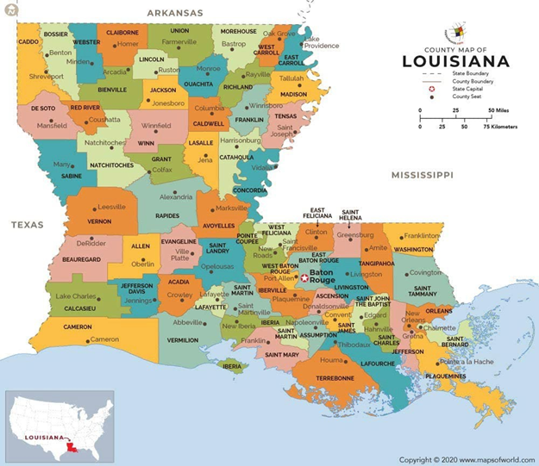

High Leverage Groups of National Applicability (HLGNA)
Louisiana’s focus populations included (a) African Americans living with HIV/AIDS; (b) African Americans with mental health conditions; and (c) African Americans living with both HIV/AIDS and mental health conditions. These populations were further characterized as:
- Culturally diverse populations
- Those receiving federal financial support through the Temporary Assistance for Needy Families (TANF) program
- Individuals receiving Supplemental Security Income (SSI) and/or Social Security Disability Insurance (SSDI)
- Persons with multiple disabilities

Primary Challenges
The combination of the challenges involved with living in poverty and other related factors created significant barriers for persons with disabilities living in Louisiana, including (a) awareness of and access to coordinated and comprehensive community support services; (b) concerns about confidentiality, stigma, and discrimination; and (c) a lack of employability skills.

Specific Goal(s) for This Project
Project E3 provided Louisiana’s state Vocational Rehabilitation agencies and their partners with the skills and competencies needed to effectively and efficiently address barriers to competitive integrated employment and community integration encountered by persons with disabilities in these regions.
The specific goals included:
- Outreach to at least 190 individuals in the targeted populations and communities.
- Increase community awareness of HIV/AIDS and/or Mental Health conditions, their effects on daily lives of clients and families, and ways to access available resources.
- Provide training and technical assistance to at least 25 vocational rehabilitation counselors, employment specialists, community outreach personnel, and selected employees of related government entities.
- Prepare and approve at least 38 Individual Plans for Employment for clients accepted for vocational rehabilitation services.
- Achieve competitive integrated employment for at least 43% of participants with HIV/AIDS and at least 40% of participants with mental health conditions.
The team leveraged promising practices, knowledge, and experience gained from this project to expand employment opportunities for individuals with disabilities from underserved and economically disadvantaged populations throughout Louisiana and across the United States.

Key Strategies to Address Barriers
The following strategies were developed and implemented to address the targeted populations' challenges and barriers to employment:
Community Based Participatory Research (CBPR): To understand a community’s issues and concerns, one needs data and information both supplied by common data sources and interpreted by the community to better understand their issues and possible solutions to those issues. CBPR’s methodology is predicated on deep and extensive community involvement in the identification of issues and concerns and in the resolution of those issues and concerns.
Job Club: UpLiftd hosted a job club in Baton Rouge and New Orleans which switched to virtual Job Club meetings to adapt to the restrictions imposed by the pandemic. According to facilitators, this format appears to work well, though current rates of participation remained relatively low in the virtual setting.
Integrated Resource Teams (IRT): To overcome misunderstandings between agencies serving persons with disabilities especially individuals with HIV and mental illness, IRTs are an excellent way to structure collaborative working arrangements as well as consider options for the blending and braiding of services and funding. As Project E3 was coming to close, Louisiana explored options for training in IRT.
Evidence Based Practice Counselor Toolkit: Mental Health First Aid Training - Mental Health First Aid is a skills-based training course that teaches participants about mental health and substance-use issues. It is a helpful tool for educating community members who are not familiar with current research and prevalence of mental illness and substance-use issues. It can help obtain buy-in to other strategies to treat mental illness.
Financial Literacy Training: Supported people to develop skills and knowledge about personal money management and helped them develop a plan for their financial future.

Site Partner Reflections
Site partner reflections for the state of Louisiana primarily focused on (a) building community connections (b) barriers to service provision, (c) training, and (d) sustainability.

Building Community Connections
Building community connections was a key feature of Project E3 in Louisiana. As an example, one administrator describes a large training in New Orleans (i.e., leadership academy) that connected community leaders and service providers to vocational rehabilitation administrators, counselors, and staff. A key takeaway from the provided opportunities to build connections was stated by one administrator as follows: “I think one of the major…takeaways…was just the sharing of information, that mutual kind of sharing of information, us gaining some information, knowledge about the population and some of the issues…just making connections.” Based on networking opportunities facilitated throughout the project, a strong relationship between vocational rehabilitation services and HIV (e.g., HIV AIDS Alliance of Region Two/Open Health Care Clinic) and mental health (e.g., Crescent Health Care) community-based organizations were established. Due to the enhanced referral pipeline, administrators assigned a dedicated counselor to consumers referred from these agencies, particularly a vocational rehabilitation counselor on staff with experience working with stigmatized populations. This counselor’s knowledge of the unique needs of the target groups and ability to primarily focus on these referrals made a significant difference in consumers matriculating from referral status to gainfully employed.

Barriers to Service Provision
Barriers to service provision, particularly for the HIV and mental health targeted communities included (a) stigma, (b) transportation, (c) difficulties meeting basic needs, (d) losing contact with consumers, (e) lack of knowledge about vocational rehabilitation, and (f) caseload size. Regarding stigma, one administrator stated “we’re human…we have biases, fear, and those kinds of things”. Thus stigma from service providers can be a barrier to outreach and then fear of stigma or disclosure can be a barrier for persons with HIV and/or mental health conditions reaching out for services. In terms of transportation, it has always been a number one barrier (e.g., “I think has always been our number one”) for service provision in the state of Louisiana. In describing difficulty meeting basic needs as a barrier to service provision, one administrator states: “if those basic needs are not met they’re not going to go and get further services even though that may help them to reach those as well”.
A specific barrier for the mental health target population was inability to sustain contact, which can occur if consumers discontinue treatment. As stated: “sometimes they decide to go off the treatment and then, you know, they don’t access us again”. As a final barrier, a lack of knowledge about vocational rehabilitation services is a barrier to consumers seeking services or community- based providers referring potential consumers to services. One administrator states: “that’s always been a huge barrier….they don’t know about you”. Lastly, caseload size is a consistent barrier to provision of vocational rehabilitation services. In the context of Project E3, administrators reflected on how caseload size may inhibit follow-up efforts of the vocational rehabilitation counselors.
Particularly for persons living with stigmatized health conditions, that additional outreach and follow-up may be needed, but large caseloads are a barrier to implementing that best practice.

Training
The training provided as a part of Project E3’s activities were extremely beneficial to key stakeholders in Louisiana (e.g., “training was exceptional”). Particularly for the HIV and mental health targeted populations, the training assisted in stigma reduction amongst vocational rehabilitation staff. As mentioned by an administrator: “folks have stereotypes and whatnot and those trainings…regarding HIV and related to mental health…really helps break down some of those barriers and to attack some of that, the negative thoughts and attitudes and biases and that kind of stuff with information…so that tremendously helped”.
A highlight of the training was sessions led by persons living with HIV and mental health conditions. Members from these targeted groups were open about their lived experiences which resonated with attendees. As stated, the presenters were “forthcoming about it” and due to that openness, attendees were able to leave the trainings with positive, personal interactions with persons living with HIV and mental health conditions (e.g., “nothing that beats positive personal interactions”). Administrators did express frustration about the limited notice provided about upcoming trainings. Due to short notice, it was difficult for some vocational rehabilitation counselors to make room on their schedule to attend. Administrators recommended at least one month in advance for these types of trainings to ensure maximum turnout.

Sustainability
In order to sustain the gains from Project E3, administrators state they want to continue to foster connections with service providers, particularly HIV and mental health services providers to solidify a strong referral network. However, in order to do so, they express the need to hire more vocational rehabilitation counselors. Although money is not an issue in hiring more staff, the low salary, particularly for graduate-level work, prohibits applicants. One administrator stated “money is not an issue” if “they want to take $14 and a quarter, tell them to call me”. Thus, sustainability efforts may be stalled until more staff can build upon the Project E3 related gains.

Sustainability, Tools, and Resources
Financial Literacy Training Tools
National Disability Institute Financial Capability Series
- Module 1: An Introduction to Financial Wellness
- Module 2: Setting Financial Goals
- Module 3: Choosing and Accessing Financial Products
- Module 4: Savings and ABLE (Achieving Better Life Experience) Accounts
- Module 5: The Importance of Good Credit
- Module 6: Using Work Incentives to Meet Financial Goals – Part 1
- Module 7: Using Work Incentives to Meet Financial Goals – Part 2
- Module 8: Protecting Your Identity

Montana

Summary of State Project
Montana's beautiful landscape includes forests, prairies, highlands, and valleys. It includes the Rocky Mountains and the Continental Divide in the western part of the state and rolling plains in the eastern part of the state. Two-thirds of Montana is in the Great Plains.
Montana's economy is primarily based on agriculture, including ranching and cereal grain farming. Other significant economic activities include oil, gas, coal and hard rock mining, lumber, and the fastest-growing sector, tourism. Health care, service, and government sectors are also significant to the state's economy. In 2011, Montana ranked third in the nation in number of craft breweries per capita.
The population in Montana is distributed over a large geographic area. Montanans living in rural areas face unique challenges to both accessing services and finding employment. These challenges are compounded for those living with disability and poverty.
Montana was chosen as a targeted community through the Vocational Rehabilitation Technical Assistance Center: Targeted Communities (VR-TAC-TC) or Project E3. Project E3 partnered with State VR Agencies and local community partners to improve outreach and employment-related services to underserved people with disabilities in this community.

Project E3 Partner
University of Wisconsin-Madison

Targeted Communities
The state-federal vocational rehabilitation system in Montana faced many challenges as it strove to serve people with significant disabilities and promote competitive integrated employment. Project E3 provided intensive technical assistance to Glacier County and Blackfeet Reservation (Region 1), and Bighorn County (Region 2).

Montana State Map Highlighting ITA Targeted Communities

Gracier County
Pondera County

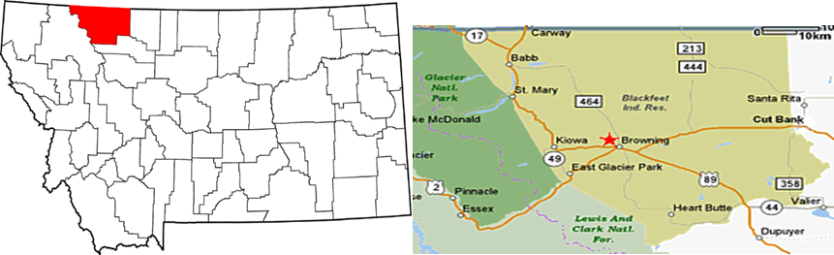

High Leverage Groups of National Applicability (HLGNA)
Montana’s focus populations included (a) persons with psychosocial impairments attributed to alcohol abuse or dependence; (b) persons with Cognitive, mobility or psychosocial impairments; and (c) persons with psychosocial impairments attributed to depression or anxiety. These populations were further characterized as:
- Culturally diverse populations
- Persons with multiple disabilities
- Residents of rural and remote communities

Primary Challenges
The combination of challenges including high poverty, disability, and unemployment rates and low post-secondary educational achievement contributed to lower successful VR case closure rates in these communities. Specific challenges were noted in the areas of:
- Limited awareness of the availability of vocational rehabilitation services
- Unstable and limited funding for the tribal vocational rehabilitation program and Blackfeet Manpower
- Fear of losing benefits through work
- Ability of vocational rehabilitation counselors to provide culturally appropriate rehabilitation services
- Limited opportunities for work and lack of knowledge of opportunities
- Lack of transportation

Specific Goal(s) for This Project
Project E3 provided Montana’s state Vocational Rehabilitation agencies and their partners with the skills and competencies needed to effectively and efficiently address barriers to competitive integrated employment and community integration encountered by persons with disabilities in these regions.
The specific goals included:
- Increase the number of applicants for vocational rehabilitation service
- Increase the number of individuals found eligible for vocational rehabilitation service
- Increase the percentage of eligible individuals who develop Individual Plans for Employment with their vocational rehabilitation counselors
- Increase the percentage of individuals with Individual Plans for Employment who obtain and retain integrated, competitive employment.
The team leveraged promising practices, knowledge, and experience gained from this project to expand employment opportunities for individuals with disabilities from underserved and economically disadvantaged populations throughout Montana and across the United States.

Key Strategies to Address Barriers
The following strategies were developed and implemented to address the targeted populations' challenges and barriers to employment:
Community Based Participatory Research (CBPR): To understand a community’s issues and concerns, one needs data and information both supplied by common data sources and interpreted by the community to better understand their issues and possible solutions to those issues. CBPR’s methodology is predicated on deep and extensive community involvement in the identification of issues and concerns and in the resolution of those issues and concerns.
Motivational Interviewing (MI): The Crow Agency identified MI as a key strategy for their staff working with persons with disabilities. This was supplemented with training on Impression Management. The Native American Motivational Interviewing: Weaving Native American and Western Practices - A Manual for Counselors in Native American Communities resource was introduced.
Impression Management Training Tools: Materials to be used with consumers to train on the importance of first impressions and how to manage this while seeking employment included (a) an outline of the Impression Management Workshop; (b) a presentation; (c) a handout covering commonly used impression management techniques; and (d) exercises on impression management techniques.

Site Partner Reflections
Site partner reflections for the state of Montana included community outreach, trainings, barriers, including specific barriers to Indigenous/Tribal populations, and sustainability.

Community Outreach
Several community events, including resource fairs, were held throughout the project, particularly in Browning. A critical element of these community events was cultural congruence. One site partner representative stated: “I know a lot of gatherings of the community and using traditional things that would be compelling for people to attend, so food, a lot of times, you know, group gatherings around food is an enticing thing for people to get to see each other and have a meal together, that’s important in that community”.

Trainings
The trainings sponsored by Project E3 were extremely beneficial for the vocational rehabilitation counselors and community-based partners. One administrator states counselors were “really appreciative of motivational interviewing and sharing what that is with our tribal partners and how to work together in that delivery of counseling theory and methods and practices”. Additionally, counselors reported the financial empowerment training was beneficial and it was “highly spoken of”.

Barriers
Barriers identified in post-project reflections included the isolation of the target populations due to the landscape of Montana, the lack of technology and adequate postal service, food insecurity, and navigating cultural differences. There are also unique barriers for Indigenous/Native populations including “generational trauma and mistrust”. To expound, one administrator described “there are still people alive there that have experienced directly the ruin of their nation”. Lack of follow-up from community events also provided a significant barrier to capitalizing on referrals. As described, “the counselors doing it did not follow procedures on application taking…they were so excited and so ready to engage with everybody in that community and stuff that some pretty important pieces of the application processes weren’t followed”.
One systematic barrier that prevents effective collaboration between vocational rehabilitation services and tribal partners is how success is currently defined by the federal government. In reflecting on this, one administrator states:
“Also, one other thing…that we’ve continually talked about with our tribal partners was…just defining success and putting resources towards things and the federal government definition of success and why isn’t bartering or in a community achieving that, why can’t we count that towards success and invest in that type of, that’s always been a frustration, I think from us, from all of us that work, because if you’re providing sustenance to the community or a service the community needs but you’re getting, you’re not getting paid but you’re getting something back from the community that you need, it doesn’t count , you know, so that is the barrier, like a way deeper barrier that gets really complicated…”

Sustainability
At the time of interview, reflections on sustainability efforts involved more ideation phases. Based on the training for Project E3 and other Montana based efforts (e.g., Promise Project), administrators can now see the importance of implementing these best practices. As an example, on administrator reports “we are working on getting internal benefits planners”as“starting point”.

Sustainability, Tools, and Resources
Impression Management Training Tools
- Outline: Impression Management Workshop
- Presentation: Impression Management Workshop
- Handout: Commonly Used Impression Management Techniques
- Exercise: Impression Management Techniques

Social Skills Workshop
- Presentation: Social Skills Workshop
- Exercise: Community Participation That Reflects Prosocial Behavior
Motivational Interviewing
- Native American Motivational Interviewing: Weaving Native American and Western Practices - A Manual for Counselors in Native American Communities

New Hampshire

Summary of State Project
New Hampshire has the highest percentage of timberland area in the country. It has some of the largest ski mountains on the East Coast so skiing, snowmobiling, and other winter sports are major tourist attractions. The fall foliage and summer cottages along many lakes and the sea are also very popular attractions. Tourism is an important part of the state’s economy.
New Hampshire is a primarily rural state, encompassing a total of 10 counties, seven of which are rural and characterized by higher poverty relative to the urban areas. The geographic isolation of New Hampshire’s rural communities poses significant challenges for persons with disabilities in achieving competitive, integrated, and lasting employment, as well as full community participation and integration.
New Hampshire was chosen as a targeted community through the Vocational Rehabilitation Technical Assistance Center: Targeted Communities (VR-TAC-TC) or Project E3. Project E3 partnered with State VR Agencies and local community partners to improve outreach and employment-related services to underserved people with disabilities in this community.

Project E3 Partner
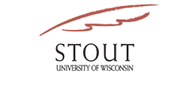
University of Wisconsin-Stout Vocational Rehabilitation Institute (SVRI)

Targeted Communities
The state-federal vocational rehabilitation system in Montana faced many challenges as it strove to serve people with significant disabilities and promote competitive integrated employment. Project E3 provided intensive technical assistance to Glacier County and Blackfeet Reservation (Region 1), and Bighorn County (Region 2).

New Hampshire State Map Highlighting ITA Targeted Communities

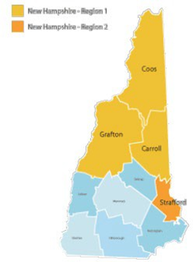

High Leverage Groups of National Applicability (HLGNA)
New Hampshire’s focus populations included:
HLGNA1: Youth with cognitive and/or psychosocial/emotional disabilities between the ages of 14- 24 who live in rural or remote communities.
- Have applied and engaged with vocational rehabilitation services at lower rates, and attained lower competitive, integrated employment outcomes, than their peers
- Includes youth who receive Supplemental Security Income (SSI) and /or are involved in foster care
HLGNA 2: Adults with cognitive and/or psychosocial/emotional disabilities ages 25 or older who live in rural or remote communities.
- Includes adults who receive SSI
- Have applied and engaged with VR at lower rates, and attained lower competitive, integrated employment outcomes, than their peers
These populations were further characterized as:
- Residents of rural and remote communities
- Individuals receiving federal financial support through the Temporary Assistance for Needy Families (TANF) program
- Individuals receiving Supplemental Security Income (SSI) and/or Social Security Disability Insurance (SSDI)
- Persons with multiple disabilities
- Transition-age youth (14-24)

Primary Challenges
The combination of the challenges above and other factors created significant barriers for persons with disabilities living in New Hampshire, including (a) geographic isolation; (b) the impacts of poverty, including limited finances and resources, community support, and unstable family structures; (c) lack of transportation; (d) limited employment opportunities; (e) inadequate training and education options; and (f) limited vocational rehabilitation services.

Specific Goal(s) for This Project
Project E3 provided New Hampshire’s state Vocational Rehabilitation agencies and their partners with the skills and competencies needed to effectively and efficiently address barriers to competitive integrated employment and community integration encountered by persons with disabilities in these regions.
The specific goals included:
- Increase the number and percentage of low-income individuals applying for vocational rehabilitation services by 10%.
- Increase the number and percentage of Individual Plans for Employment (IPE) developed and implemented with participants by 10% each year.
- Increase the number and percentage of participants who successfully achieve their competitive, integrated employment goals by 10% each year.
The team leveraged promising practices, knowledge, and experience gained from this project to expand employment opportunities for individuals with disabilities from underserved and economically disadvantaged populations throughout Montana and across the United States.

Key Strategies to Address Barriers
The following strategies were developed and implemented to address the targeted populations' challenges and barriers to employment:
Community Based Participatory Research (CBPR): To understand a community’s issues and concerns, one needs data and information both supplied by common data sources and interpreted by the community to better understand their issues and possible solutions to those issues. CBPR’s methodology is predicated on deep and extensive community involvement in the identification of issues and concerns and in the resolution of those issues and concerns.
Community Outreach and Orientation: Vocational Rehabilitation held a series of meetings with organizations serving youth to ascertain roles, confidence in their abilities to work collaboratively across schools and agencies going forward, and confidence in ability to help the young people they serve. This would be the basis for future training and collaborative arrangements.
Financial Literacy Training: Vocational Rehabilitation and their community-based partners identified financial literacy as a priority strategy and used a curriculum developed and made available by the Consumer Financial Protection Bureau (CFPB) to train staff.

Site Partner Reflections
Site partner reflections for the state of New Hampshire focused on strengthening community connections, barriers and sustainability.

Strengthened Community Connections:
There was an overall excitement expressed from community-based organizations to come together “in a multi-, you know, interagency way” because “there’s a collaboration and coordination that needs to happen between VR and these other agencies…community mental health centers and area agencies for people that have significant intellectual developmental disabilities”. As other services are “focused on clinical…therapeutic stuff…what their housing situation is…what is their service plan…those stakeholders have to be involved in helping with the employment path”. Strengthened community partnerships also led to formalized agreements between partner agencies.

Barriers:
Slow implementation and gaps in implementation of project activities with community partners which “disappointed the local agencies because they, everybody was gung-ho and got excited and then felt like, ugh, you know, very much like bummer, you know, professionally because everything, the pause button was hit, literally, on how are we going to do this”.
“So, I would say that there was somewhat of a vacuum, so it was sort of like VR was like the lone employment focus, you know, and so I would say that was a barrier, that, you know, to be able to make bigger impact and better serve the populations and locations that E3 targeted. It required bringing leaders together, not just VR leadership but other agency leadership, which we did. We had the executive directors of both of those large organizations, community partners and northern human services, their EDs got involved and said, this is a priority for us, we want all of our staff to be going to these trainings, we want them to be working out these solutions, you know, we need to maximize VR resources and the context of transition-age planning with local school districts and with young adults. So that, I would say that was a barrier, before E3 came in, that that relationship wasn’t in sync as much as would have been desirable and as it had in the past. So that was a barrier.”
“Another really big barrier is, at that time we had very, very, very low unemployment. New Hampshire was one of those states with the lowest unemployment in the country. So, direct, having staff and, you know, for VR to hire vendors, you know, who were in the role of, you know, CRPs, community rehab professionals, and high-quality job developers, that was problematic from the standpoint of having a workforce, you know, a stable workforce of highly trained employment professionals with the vendors that VR contracts with. They were really suffering, many of the vendors across the state in New Hampshire were really suffering with, you know, having difficulty retaining employment service providers, so that was a big barrier. Obviously COVID hit and it was like, oh, boy.”

Trainings:
All agencies and community partners participating in New Hampshire reported a strong liking and endorsement for the trauma-informed care training and Covid-19 related training provided through the project, “So prior to working with E3, I would say, like I said, there was sort of a leadership vacuum, not, and I’m not saying [Name] wasn’t focused on employment, because [s/he] was. It’s the interagency aspect of it is what I’m referring to. You know, so I would say, you know, to have, there was a missing convener bringing people together at the community and statewide level to really focus on employment. You know, everyone was kind of, I would say, siloed, doing their own thing, you know, what their agency did and focused on who they serve individually and not necessarily systematically as a system, as a community-based system”. Staff also reflected on the use of Practice Profiles across agency interagency staff.

Sustainability:
Procuring additional funding to extend services was noted as a key sustainability effort, “Yeah, we just got the TPSID award. I don’t know if you’re familiar with TPSID but that’s the big award from the U.S. Office of Postsecondary Education, so a lot of the work with, you know, VR and partners to that award. Yep, it is, and we have, part of that TPSID award, which all this led up to, and VR was the first, one of the first financial partners to make this happen, we have the entire community college system on board.”
Site staff also noted the importance of implementing a new “BRIDGE” program, “We have a bridge program that we’re implementing that started October 1st, so it’s total remote. It’s not through your, you know, model that we are planning to implement next fall, but it is a bridge program. It’s preparing people for college. It’s inclusive. So that started October 1st, and we’ve got 17 students enrolled in that. They’re all doing virtual learning on three different classes, and with peer mentors involved, other matriculated UNH students are assisting them in their activities class”.

Sustainability, Tools, and Resources
- New Hampshire Financial Literacy Training Your Money, Your Goals (PowerPoint)
- University of New Hampshire’s UNH-4U Think College Program for Students with IDD

New Jersey

Summary of State Project
New Jersey, also known as “The Garden State'', is among the leaders in many types of agricultural production. The state is a peninsula, bordered by the Atlantic Ocean in the east, southeast, and south. New Jersey is the fourth smallest state in area and the 11th most populous of the 50 states. The geographic location and factories in cities helped to drive the Industrial Revolution. Today, New Jersey is one of the most ethnically and religiously diverse states in the country.
With a median household income of $76,126 in 2016, well above the national average, and a poverty rate of about 10 percent, New Jersey is the second-wealthiest state in the country. In spite of this, large populations in New Jersey experience unemployment rates higher than the national average and median household incomes far below the federal poverty level.
New Jersey was chosen as a targeted community through the Vocational Rehabilitation Technical Assistance Center: Targeted Communities (VR-TAC-TC) or Project E3. Project E3 partnered with State VR Agencies and local community partners to improve outreach and employment-related services to underserved people with disabilities in this community.

Project E3 Partner
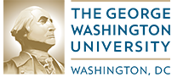
The George Washington University

Targeted Communities
The state-federal vocational rehabilitation system in New Jersey faced many challenges as it strove to serve people with significant disabilities and promote competitive integrated employment. Project E3 provided intensive technical assistance to the cities of Newark (Region 1) and Trenton (Region 2).

New Hampshire State Map Highlighting ITA Targeted Communities

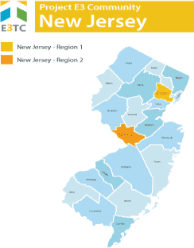

High Leverage Groups of National Applicability (HLGNA)
Within New Jersey, Project E3 focused on improving vocational rehabilitation service outcomes for (a) individuals with drug and alcohol abuse/dependence who receive Social Security disability benefits, and (b) persons with mental illness who receive Social Security disability benefits. These populations were further characterized as:
- Consumers receiving federal financial assistance through TANF
- SSI and SSDI recipients
- Persons with multiple disabilities

Primary Challenges
The combination of the challenges involved with living in poverty and other related factors created significant barriers for persons with disabilities living in New Mexico, including (a) impacts of poverty, including limited finances and resources, community support, and unstable family structures, (b) lack of information about disability and vocational rehabilitation resources, (c) limited transportation options, (d) discrimination or stigma surrounding substance abuse and dependence, (e) negative attitudes among employers toward employment of persons with disabilities, and (f) fear of losing cash and health benefits through work.

Specific Goal(s) for This Project
Project E3 provided New Jersey’s state Vocational Rehabilitation agencies and their partners with the skills and competencies needed to effectively and efficiently address barriers to competitive integrated employment and community integration encountered by persons with disabilities in these regions.
The specific goals included:
- Increase participation in State vocational rehabilitation programs of people with disabilities from low-income communities, focusing on individuals who are the most impoverished and economically disadvantaged
- Increase support services provided by community agencies to people with disabilities from low-income communities
- Increase the number of people with disabilities from low-income communities who complete their vocational rehabilitation program and achieve competitive integrated employment
- Increase coordination between vocational rehabilitation programs and community agencies to provide better support to individuals
The team leveraged promising practices, knowledge, and experience gained from this project to expand employment opportunities for individuals with disabilities from underserved and economically disadvantaged populations throughout New Jersey and across the United States.

Key Strategies to Address Barriers
The following strategies were developed and implemented to address the targeted populations' challenges and barriers to employment:
Community Based Participatory Research (CBPR): To understand a community’s issues and concerns, one needs data and information both supplied by common data sources and interpreted by the community to better understand their issues and possible solutions to those issues. CBPR’s methodology is predicated on deep and extensive community involvement in the identification of issues and concerns and in the resolution of those issues and concerns.
Poverty and Disability: Bridges Out of Poverty – It is difficult for many individuals including professionals in the field to understand the extent of challenges facing individuals living in poverty and trying to work their way out of poverty. “Bridges Out of Poverty” is excellent training on cultural responsiveness for working with people and communities that experience poverty. It is a proprietary training program so for more information click on this link: aha! Process - Poverty Reduction Professional Development and Solutions (ahaprocess.com
Trauma Informed Care: New Jersey identified this as a needed strategy for adding expertise to their counseling approaches. New Jersey VR, Workforce, Independent Living Centers and community providers attended a remote training. After receiving training, training participants discussed ways to apply in their daily work as well as sustain TIC going forward.
Community Outreach and Orientation: Community buy-in and support needs constant attention as community members change and new members are added. George Washington University actively engaged Vocational Rehabilitation, community partners, Workforce agencies and Independent Living Centers and Social Services in the targeted communities in regular meetings to discuss progress, accomplishments and methods for sustaining the outreach and collaboration when the E3 grant ended..

Site Partner Reflections
New Jersey vocational rehabilitation stakeholders did not participate in a final interview about services for this programmatic report. However, they did create a short video for the Leadership Academy that provided some helpful contextual information to highlight the impact of Project E3 in the state. New Jersey’s first HLGNA included consumers with drug abuse/dependence and alcohol abuse and dependence receiving SSI. New Jersey’s second HLGNA included persons with mental illness receiving SSI. In this video, accomplishments and sustainability efforts were highlighted as follows.
Accomplishments:
New Jersey stakeholders were able to accomplish the following throughout the course of Project E3:
Expand efforts of the Disability Issues Subcommittee of the Workforce Development Board (Newark & Essex County) by Adding Members to Expand Community Partnerships/Outreach
From the video: “As chair -- co-chair– of our disability issues subcommittee of the workforce development board, one of the most positive outcomes that we saw was expanding the efforts of our committee to include additional members who had -- who had not before participated and also to expand community partnerships and outreach”.
Facilitate cross training opportunities between partners in the Workforce Development System
From the video: “In terms of what we have done and what we want to see continued, we're going to be working on cross-training opportunities between partners in the workforce development system, and one of the really positive results is that we brought together members of the council public and private partners in order to help extend our reach.”
Increase employment participation rates for individuals with disabilities between the public Workforce System and Community-based Organizations.
From the video: “What we also saw was increased employment participation rates for individuals with disabilities in the public workforce system and in community- based organizations. We had individuals particularly in the public workforce system who had very limited if any connection with working with individuals who have disabilities and by participating and going through the training that was provided, they really learned a great deal about the types of services that individuals with disabilities can use and how much -- much of these services are available in the public workforce system”.

Increase awareness around serving individuals with disabilities via cross-training opportunities
From the video: “We also did a lot of cross-training that was helpful to increase awareness around serving the individuals with disabilities that hopefully will be positively impacted by this program”.

Sustainability
In terms of sustainability, New Jersey administrators report the following steps to ensure the sustainability of their efforts:
Develop a Community Academy (when in-person events are again possible.)
From the video: “So in terms of sustainability, we do plan to put together a community academy once we're able to go in-person again, right now many of the agencies are providing virtual services, so we are looking forward to being able to host a community academy…”
Search for other opportunities to engage with training and technical assistance.
From the video: “...we're also looking for other opportunities to engage with training and technical assistance.”
Continue regular meetings of the Disability Issues Subcommittee
From the video: “The disability issues committee will be continuing, and it is hoped that we will be able to look at additional opportunities as a result of our regular committee meetings.”

New Mexico

Summary of State Project
New Mexico is one of the Mountain States. The landscape ranges from deserts, to mesas, to high, snow-capped mountains. New Mexico has large Native American and Hispanic populations.
The discovery of oil in 1928 led to oil and gas production in New Mexico. More recently, several industry clusters are growing and thriving, thanks to competitive incentives, world-renowned laboratories and research facilities, an innovative entrepreneurial scene, and a highly skilled workforce. A few of these include customer service centers, solar technology and renewable energy, and microsystems and nanotechnology.
New Mexico's disability rate in 2014-16 was 10% in the state and 13.5% among Hispanics. The state's poverty and unemployment rates are higher than national averages.
New Mexico was chosen as a targeted community through the Vocational Rehabilitation Technical Assistance Center: Targeted Communities (VR-TAC-TC) or Project E3. Project E3 partnered with State VR Agencies and local community partners to improve outreach and employment-related services to underserved people with disabilities in this community.

Project E3 Partner
Southern University-Baton Rouge

Targeted Communities
The state-federal vocational rehabilitation system in New Mexico faced many challenges as it strove to serve people with significant disabilities and promote competitive integrated employment. Project E3 provided intensive technical assistance to two regions of the state: Albuquerque (Region 1) and Deming (Region 2).

New Hampshire State Map Highlighting ITA Targeted Communities

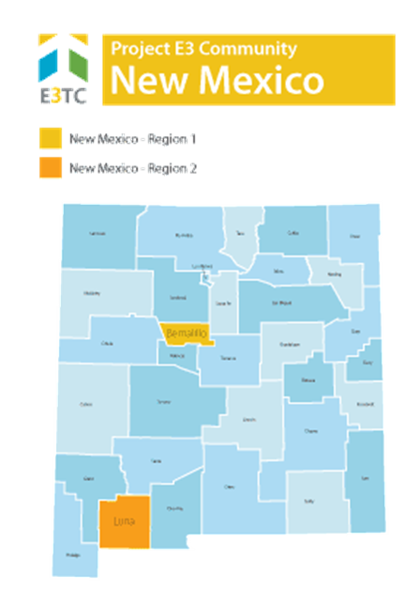

High Leverage Groups of National Applicability (HLGNA)
New Mexico’s focus populations included (a) persons with a primary disability of anxiety disorder, depressive disorder, personality discords, and/or other mood disorders, and (b) persons with a primary disability of alcohol abuse or drug dependence. These populations were further characterized as:
- Culturally diverse populations
- High school dropouts and functionally illiterate consumers
- Persons with multiple disabilities
- Residents of rural and remote communities
- SSI and SSDI recipients
- Subminimum Wage Employees

Primary Challenges
The combination of the challenges involved with living in poverty and other related factors created significant barriers for persons with disabilities living in New Mexico. The effects of lack of financial capability for these populations often translated into (a) lower levels of education, (b) higher prevalence of disability, (c) lower access to health insurance, (d) greater food insecurity, (e) higher prevalence of homelessness, and (f) significantly less awareness of public support programs.

Specific Goal(s) for This Project
Project E3 provided New Mexico’s state Vocational Rehabilitation agencies and their partners with the skills and competencies needed to effectively and efficiently address barriers to competitive integrated employment and community integration encountered by persons with disabilities in these regions.
The specific goals included:
- Increase awareness of social support networks available to people with disabilities
- Help people with disabilities apply for needed services
- Increase interest in learning time management, money management, medicine management, public transportation, social skills, and good hygiene
- Improve individual ability to find, apply, and be interviewed for employment
- Improve access to vocational rehabilitation supports
- Inform employers in the community about the benefits of employing people with disabilities.

Key Strategies to Address Barriers
The following strategies were developed and implemented to address the targeted populations' challenges and barriers to employment:
Community Based Participatory Research (CBPR): To understand a community’s issues and concerns, one needs data and information both supplied by common data sources and interpreted by the community to better understand their issues and possible solutions to those issues. CBPR’s methodology is predicated on deep and extensive community involvement in the identification of issues and concerns and in the resolution of those issues and concerns.
Integrated Resource Teams: Casa de Phoenix (CdP) staff were trained on the IRT model and implemented the model with residents of their program. Until the end of the grant, Project E3 provided coaching of the IRT model to lead counselors of NM-DVR, as well as staff of CdP and NM Workforce Connection. IRT implementation occurred in both Albuquerque and Demining, NM.
Work Incentive Benefits Counseling: NM Workforce Connection in Albuquerque partnered with Project E3 to develop a Benefits Advisor position in their One-Stop Center. The initiative was postponed due to the impact of COVID-19 on operations of the Center. However, leadership from the Center entered into a contractual agreement with Project E3 to create this position. Project E3 will fund up to .50 FTE of the salary and fringe costs of that staff person until the end of the grant and NM Workforce Connection will fund the other .50 FTE.
Job Clubs: A Job Club was launched at CdP. Residents participated in a curriculum that was developed collaboratively between Project E3 staff and Hopeworks staff. E3 staff provided on- going coaching during the rollout to promote a successful implementation and sustainability of the Job Club.

Site Partner Reflections
Site partner reflections from the state of New Mexico focus on barriers, training, system-level changes, and sustainability.

Barriers
In describing barriers to service provision, there is a differentiation between systemic barriers within vocational rehabilitation and barriers specific to the targeted community populations. In terms of systemic barriers, one administrator describes how nationally, vocational rehabilitation has “always struggled with service to people with mental illness and even more so to people with substance abuse”, particularly sobriety restrictions for service provision. At the state level, one systemic barrier is the “state mental health system essentially removed all employment-related activities”. For barriers related to targeted communities, holistically, there is “just a lack of opportunity”. For instance, due to seasonal employment and “high migrant worker population”, unemployment rates are particularly high. It isn’t uncommon for individuals to work seasonally, then get laid off, and eventually collect unemployment until more seasonal work-related opportunities present themselves. As stated by an administrator: “It’s a cultural thing and most of the families really aren’t interested in doing anything different than that kind of I guess routine, per se”.
Administrators provided additional commentary of barriers related to community-based providers operating in “silos” and lack of knowledge about services. As a goal within Project E3, administrators prioritized “getting everyone on the same page”. Overall, knowledge about services was also identified as a systemic barrier and is connected to community-based organizations operating in silos.

Training
One training initiative that grew from Project E3 was the community academy which provides outreach to providers, conducted virtually due to the COVID-19 pandemic. Administrators were able to learn from the principles of the leadership academy, sponsored by Project E3, with technical support from Project E3 staff (e.g., Dr. John Walsh), and utilize that framework for engaging local community-based providers. Administrators also supported trainings for vocational rehabilitation staff including Bridges Out of Poverty, trauma-informed care, Social Security benefits training, and training related to the Americans with Disabilities Act.

System Level Changes
Streamlining the referral process for services was a major system level change. As described by one administrator, “we weren’t really able to keep track of referrals back and forth…and we were able to use the form…developed, and to get the state workforce board to agree that would be an acceptable means of referral back and forth to one another, and by simply changing the name and address and contact number at the top of the form for each office, we were able to roll that out statewide as a temporary stop gap”. With this streamlined referral process, that essentially involves a form change, staff were able to pre-screen, monitor and track referrals with “an automated workflow that goes to the respective partner that best serves that individual, because regardless of their behavioral health needs there’s so many different ways and directions they can go as far as employment and career services”.

Sustainability
As a part of sustainability efforts, New Mexico vocational rehabilitation services, particularly in Deming, will implement the TRAILS (Teaming Resources for Alignment through Integrated and Leverages Services). Via a phase-based approach, administrators will begin with the community academy, expand the integrated resource team, and implement the TRAILS model. Based on the integrated resources team framework, one administrator states “it’s actually led into other projects…one of them was DVR being in a joint referral system with workforce, in the central area, so that’s huge”. Continuing to streamline the referral process is also a major priority regarding sustainability efforts, particularly enhancing the technology to facilitate this process electronically.

North Carolina

Summary of State Project
North Carolina boasts scenic beauty, a moderate climate, a culture rich in history and the arts, and world-class sports and recreational opportunities. With 300 miles of Atlantic coastline and the highest mountain peaks east of the Rockies, it is the 6th most-visited state in the nation. North Carolina has the 9th largest economy in the United States. It is the United States’ top producer of sweet potatoes and the 2nd largest producer of Christmas trees.
There has been a clear division in the economic growth of North Carolina's urban and rural areas since 2000. Urban areas show steady job growth, low unemployment, and rising wages, while many rural counties have experienced job loss, rising levels of poverty, and population loss as their manufacturing base has declined. Predicted employment growth areas include health and medical services, professional services, wholesale/retail trade, and construction-related industries. Construction is projected to be one of the fastest growing industries in the state, and healthcare support occupations and healthcare practitioners are projected to be the two fastest growing occupational groups.
North Carolina was chosen as a targeted community through the Vocational Rehabilitation Technical Assistance Center: Targeted Communities (VR-TAC-TC) or Project E3. Project E3 partnered with State VR Agencies and local community partners to improve outreach and employment-related services to underserved people with disabilities in this community.

Project E3 Partner
The University of Wisconsin-Stout Vocational Rehabilitation Institute (SVRI)

Targeted Communities
The state-federal vocational rehabilitation system in North Carolina faced many challenges as it strove to serve people with significant disabilities and promote competitive integrated employment. Project E3 provided intensive technical assistance to the West Mountain Region encompassing Allegheny, Ashe, Avery, Mitchell, Watauga, Wilkes, and Yancey counties (Region 1) and the East counties of Edgecombe, Halifax, Nash, and Northampton (Region 2).

North Carolina State Map Highlighting ITA Targeted Communities

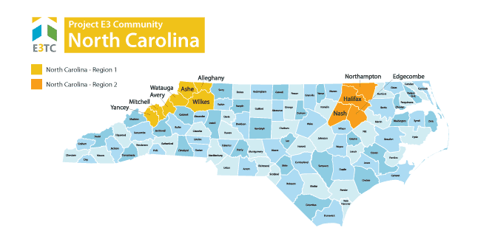

High Leverage Groups of National Applicability (HLGNA)
North Carolina’s focus populations included (a) students or youth between the ages of 14-24 with a mental health diagnosis or blindness/low-vision who had applied, were eligible for, or receiving SSI benefits; and (b) adults between the ages of 25-64 with a mental health diagnosis or blindness/low- vision who had applied, were eligible for, or receiving SSI benefits. These populations were further characterized as:
- Residents of rural and remote communities
- Consumers receiving federal financial assistance (TANF)
- SSI and SSDI recipients
- Persons with multiple disabilities

Primary Challenges
Some of the challenges of this population in North Carolina included:
- Lack of information in the community about disability and vocational rehabilitation resources.
- Minimal opportunities for financial literacy and economic empowerment opportunities through vocational rehabilitation services.
- Scarce information about employment and work incentives for youth with disabilities.
- Lack of cross-agency training/coaching in the areas of generational poverty, financial empowerment, and self-advocacy.
- Limited access to employment, training, and educational opportunities due to rural and remote locations.
- Lack of transportation options.

Specific Goal(s) for This Project
Project E3 provided North Carolina’s state Vocational Rehabilitation agencies and their partners with the skills and competencies needed to effectively and efficiently address barriers to competitive integrated employment and community integration encountered by persons with disabilities in these regions.
The specific goals included:
- Strategically reaching out to 10% of the eligible populations.
- Increase the number and percentage of low-income individuals in the targeted populations applying for vocational rehabilitation services by 10%.
- Increase the number and percentage of Individual Plans for Employment developed and implemented by participants each year by 10%.
- Increase the number of participants who achieve their competitive, integrated employment goals by 10% each year. With youth and student participants, the employment outcome may represent a short-term outcome; not necessarily reflect case closure and full gain attainment.
- Increase the number of students participating in Workforce Innovation and Opportunity Act (WIOA) pre-employment transition services by 10% each year.
- Increase the number of individuals successfully achieving measurable skills gains leading to a credential or employment.
- Increase the number of individuals who successfully attained a credential. Increase the number of individuals successfully who achieved measurable skills gains.
- Increase the number of participants who earned above minimum wage as well as those having access to employer-sponsored benefits such as insurance, paid leave, etc.

Key Strategies to Address Barriers
Community Based Participatory Research (CBPR): To understand a community’s issues and concerns, one needs data and information both supplied by common data sources and interpreted by the community to better understand their issues and possible solutions to those issues. CBPR’s methodology is predicated on deep and extensive community involvement in the identification of issues and concerns and in the resolution of those issues and concerns.
Trauma Informed Care: North Carolina identified this as a needed strategy for adding expertise to their counseling approaches. After receiving training, NC discussed ways to apply in their daily work (uses of ACES as an example) as well as sustain TIC going forward (e.g., part of new counselor training package and a checklist).
Financial Literacy Training: After receiving the “Your Money, Your Goals” training staff thought that the budgeting worksheets, SSI Benefits Estimator and ABLE accounts would be most beneficial. Materials were shared with local partners to spread the work about financial empowerment. Staff intended to use parts of the training in their daily work.
Motivational Interviewing: Provided introductory information about MI and found it improved the Client Counselor interactions and addressed client concerns. Considered providing more in-depth training to further embed MI principles in daily work.
Self-Employment: North Carolina garnered community support and resources with day -long sessions “Resources For Entrepreneurs With Disabilities” in Boone and Rocky Mount. Sessions brought together bankers, community development corporations, Chambers of Commerce, etc. to describe their services and meet VR staff
Job Exploration Counseling: Innovative Strategies for Job Placement – 20 for 20 in 2020 – North Carolina found innovative strategies for job placement in a presentation by Ashley Cross at the 2019 Leadership Academy. In addition to training provided by Ms. Cross, North Carolina tested and expanded a creative strategy “20 for 20 in 2020”. This strategy had counselors pick 20 cases from their current caseload that they would focus extra attention to gain employment in 2020.

Site Partner Reflections
Site partner reflections included a focus on community connections, training, and ideation regarding future sustainability.

Community Connections
Via Project E3 initiatives, existing community partnerships were strengthened and new partnerships developed. For existing partnerships, vocational rehabilitation counselors and benefits specialists worked closer together. In the creation of new partnerships, via Project E3 initiatives, one administrator states: “I think one of the things I saw is that it brought the players together in one venue to allow them the opportunity because they may not have been aware of the other resources as well, but it did bring a group of different resources and people together to better understand who did what, who they were, match some faces to the business, and expanded the knowledge base for everybody there”.

Trainings
Trainings offered/organized by Project E3 staff was beneficial for the vocational rehabilitation counselors and invited community partners. Particularly, the trainings on trauma-informed care, financial empowerment, and leadership training.
- For the training on trauma-informed care, counselors reported: “They felt it was a good training, and in terms of benefiting this population they felt that it provided awareness for how adverse childhood experiences impact individuals’ lives, so because we are a counseling agency with the goal of producing, you know, successful outcomes, and you can’t produce successful outcomes unless you approach things, you know, holistically, you know, if people are having issues, you know. We help them go to work but if they’re having, you know, issues within the family or in the community or just mental health triggers in general, many staff felt that the trauma-informed care would help to generate that conversation with them to pull out things that may be barriers and helping them to move forward towards employment”.
- For the training on financial empowerment, increasing the comfort level of counselors to broach financial concerns with consumers was beneficial. One administrator reflects: “It was more of a comfort level of how much training we have ourselves on financial empowerment. You know, especially with trying to tell someone how to financially be sound as a VR counselor is kind of difficult just because we weren’t, we’re not taught that in the rehab process, so I think that was another just very uncomfortable reaching out to clients about their financial situation, not knowing now the literature that we got was fantastic, and we provided quite a few, you know, information to consumers, you know, stating to them how to, you know, reach out to certain, you know, specialists and how to do that, but it was just us going through the actual booklet with them and process with them was a little uncomfortable”.
- For the leadership training, it was not necessarily new information presented to counselors but a refresher on tools and resources that would be effective to work more collaboratively. As reported by one administrator: “I’ve heard the takeaway from that, you know, what they put here definitely wasn’t really new information but it helped to hear the information again and be refreshed upon it and to talk about the strategies again for reinforcement and to make it more relevant and, you know, pertinent to specific difficult and challenging cases and stuff like that. put a lot of focus on teamwork just to really let everyone know that it’s not just one person that’s trying to place this person, that we’re in this together kind of as a counselor or BSR, everybody kind of working together and it has brought a lot more teamwork in our placements, which is fantastic, I feel, just because it is hard for one person to stay focused and, you know, not get frustrated when they can’t place a difficult client. So it’s kind of brought that back and brought it into our placement meetings, you know, what’s the barriers, how can we overcome them, and kind of using each other’s own skills. We’ve really enjoyed that”.

Sustainability
At the time of interview, sustainability efforts were in the ideation stage with several considerations including scheduling regular meetings with community partners, expanding the intake form to consider issues related to trauma-informed care, and integrating monthly placement meetings, as modeled by the Winston-Salem office, statewide to foster greater collaboration and teamwork.
- For scheduling regular meetings, one administrator reflects: “I wonder would having a regular forum or regular maybe, you know, just regular meetings with the community entities together as a group regularly to kind of problem-solve together, get to know each other, build comfort in working with, you know, the different providers and different agencies and for people to get to know each other, so that when we do have cases that require these specialized services, you know, it will be greater ease in, you know, connecting the client to those service providers”.
- For expanding the intake form to address issues related to trauma-informed care, initial thoughts from administrators are as follows: “Once people had that training we looked at the forms that we used for the intake process and there are not questions on there that would relate to anything related to mental health, other than the health checklist, you know, basically. If you don’t draw out questions related to triggers and issues that, you know, would fall under trauma-informed care, then it’s not going to be a catchment area on our intake forms, and so there was some discussion and consideration of possibly looking at, you know, making some slight revisions to the intake forms, to make sure that we’re not missing important factors that is going to impact, you know, the employability’.
- For integrating monthly team meetings, in the Winston-Salem office, they… “meet once a month, and this is just an opportunity for us to discuss those barriers, discuss each case that everybody has been referred to, what they’re working on, just kind of get everybody’s, you know, take on what’s going on with the consumer and just get some new, fresh eyes on if we’re having a difficult time placing one, you know, specific consumer. To expand statewide, initial conversations with the director include discussing “making this agency-wide strategic situation where we would have, getting all the counselors and job placement people in regular meetings to problem-solve on difficult cases and strategize together how to best approach it in terms of reaching an employment outcome, so it is going to be a bigger initiative in the months to come and we do have a job placement specialist, program specialist, in place that’s going to lead this project”.

Sustainability, Tools, and Resources

North Carolina Project E3:
- Poverty, Disability, and CBPR
Financial Literacy Training
- Presentation: Financial Empowerment
Job Exploration Counseling
- Presentation: Creative Customer Service
Motivational Interviewing
- Motivational Interviewing Change Questionnaire
- Presentation: Motivational Interviewing
- Presentation Slides: Motivational Interviewing
Self-Employment
- Agenda - Entrepreneurial Resources Event - Boone
- Agenda - Entrepreneurial Resources Event - Rocky Mount

Oregon

Summary of State Project
Oregon is in the Pacific Northwest on the West Coast. It is primarily a rural state and is one of the most geographically diverse states with volcanoes, dense evergreen and mixed forests, many bodies of water, high deserts, and semi-arid shrublands. The generally mild climate and variety of natural landscapes makes Oregon a beautiful and popular place to visit.
Oregon’s economy is mainly driven by agriculture, fishing, and hydroelectric power. It is also one of the largest timber producers in the United States.
Oregon was chosen as a targeted community through the Vocational Rehabilitation Technical Assistance Center: Targeted Communities (VR-TAC-TC) or Project E3. Project E3 partnered with State VR Agencies and local community partners to improve outreach and employment-related services to underserved people with disabilities in this community..

Project E3 Partner
The University of Kentucky, Lexington

Targeted Communities
The state-federal vocational rehabilitation system in Oregon faced many challenges as it strove to serve people with significant disabilities and promote competitive integrated employment. Project E3 provided intensive technical assistance to the Southwest Oregon counties of Jackson, Josephine, Klamath, and Douglas (Region 1) and the Central Oregon counties of Deschutes, Jefferson, and Crook (Region 2).

Oregon State Map Highlighting ITA Targeted Communities

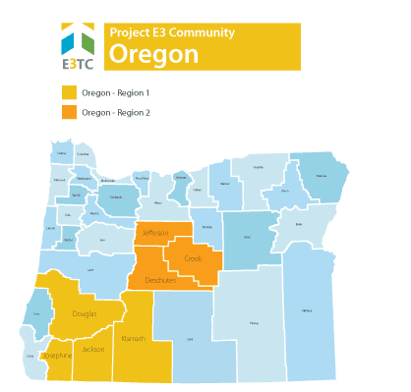

High Leverage Groups of National Applicability (HLGNA)
Louisiana’s focus populations included (a) students or transition-aged youth between the ages of 14- 24 with specific sensory impairments including blindness or other visual impairments or deaf- blindness, and were seeking vocational rehabilitation services; and (b) adults over age 24 with specific sensory disabilities including blindness or other visual impairments. These populations were further characterized as:
- Residents of rural and remote communities
- Consumers receiving federal financial assistance (TANF)
- SSI and SSDI recipients
- Persons with multiple disabilities

Primary Challenges
Some of the challenges of this population in Oregon included:
- The broad impacts of poverty in its interaction with blindness and vision disability in the rural and remote areas of Oregon.
- The inability of vocational rehabilitation services to forecast the pipeline of students with blindness/visual impairment emerging into transition age.
- Lack of information to the community about disability and vocational rehabilitation resources.
- Limited transportation options for travel to employment, training, and employment-related services.
- Negative attitudes among employers toward employment of persons with disabilities.
- Limited work skills, work experience, and understanding of employer expectations.
- Restricted opportunities for accessing adaptive equipment and rehabilitation technology and limited opportunity for training in its use.

Specific Goal(s) for This Project
Project E3 provided Oregon’s state Vocational Rehabilitation agencies and their partners with the skills and competencies needed to effectively and efficiently address barriers to competitive integrated employment and community integration encountered by persons with disabilities in these regions.
Our specific goals for this project were to:
- Increase applications by new or returning applicants who are found eligible for vocational rehabilitation services.
- Increase the number of participants who have closed cases and receive employer provided insurance at closure.
- Increase the average earnings of participants at closure.
The team leveraged promising practices, knowledge, and experience gained from this project to expand employment opportunities for individuals with disabilities from underserved and economically disadvantaged populations throughout Oregon and across the United States.

Key Strategies to Address Barriers
The following strategies were developed and implemented to address the targeted populations' challenges and barriers to employment:
Community Based Participatory Research (CBPR): To understand a community’s issues and concerns, one needs data and information both supplied by common data sources and interpreted by the community to better understand their issues and possible solutions to those issues. CBPR’s methodology is predicated on deep and extensive community involvement in the identification of issues and concerns and in the resolution of those issues and concerns.

Transportation: Transportation is regularly cited as the number one barrier for persons with disabilities. Working with Oregon, Kentucky developed a series of transportation modules and successful practices which help address the issue. The transportation modules were tailored to the needs and issues in Oregon.
Integrated Resource Teams: To overcome shortage of resources, overlapping services, lack of information, and coordinated planning, Integrated Resource Teams (IRTs) are an excellent way to structure collaborative working arrangements as well as consider options for the blending and braiding of services and funding. IRT membership depends on the locale and existing working relationships and can include Vocational Rehabilitation, education, social services, Workforce, faith- based organizations, mental health agencies, veteran’s agencies, etc. Oregon received on-going training and support on the use of IRT in their daily work.
Community Outreach and Orientation: Community buy-in and support needs constant attention as community members change and new members are added. Oregon actively engaged Vocational Rehabilitation and community partners in regular discussions of issues and common methods to help resolve those issues. The pandemic caused a switch to virtual meetings.

Site Partner Reflections
Oregon vocational rehabilitation stakeholders did not participate in a final interview about services for this programmatic report. However, they did create a short video for the Leadership Academy that provided some helpful contextual information to highlight the impact of Project E3 in the state.
Oregon’s first HLGNA included students or transition-aged youth (aged 14-24 at the time of contact with Project) who are residents of rural & remote communities, and who have specific sensory impairments including (1) Blindness, (2) Other visual impairments, or (8) Deaf-Blindness, seeking VR services.. Oregon’s second HLGNA included adults over age 24 who have specific sensory impairments including (1) Blindness, (2) Other visual impairments, who are residents of rural & remote communities.

Priority Areas:
IRT (Integrated Resource Team) Development
As reported, the IRT development process occurred primarily during the initial intake meeting based on the following core components: start early, schedule a meeting, express the common goal(s) among IRT members, sum up the plan, and share the success(es).
From the video: “Starting with the intake interview, schedule a half hour more on your time allotted. During it, ask for the client's input on their needs while potential IRT members, if you have the time with the client there, right after the intake, let them hear the client on speakerphone, so they're motivated to participate in a meeting. When you do meet, express your common goals and sum up the plan to meet those goals and share, share, share the successes”.
Community Outreach and Peer Mentoring
From the video: “Peer mentoring is on an upswing in the form of virtual workshops, flash online job events and feedback following those events by peer groups. The ESDs, education service districts, are starting to refer transition-aged youth again, and we've connected them with all of the VR resources available as well as have done virtual intakes”.

Transportation Resources in Rural Communities
From the video: “The University of Kentucky put together a bodacious transportation resource listing for Oregon”.
Administrators discussed transportation resources such as Dial-A-Ride, Uber/Lyft, and cab although they report costs for some of these service as not sustainable (e.g., “some live so far out that a four-mile ride on Uber or Lyft will cost them $15 each way, which is not sustainable”).
Innovative sustainable strategies to combat transportation challenges are effective, but must be individualized (e.g., “I've associated with cab companies for reduced fares on regular customers. One client gets picked up at 4:40 AM to be at work by 5:00 AM and as an A&D counselor, and she is able to ride the bus to go home, so it's a $13 cab ride to work and a dollar bus ride home, which is sustainable for her at $22 an hour.”).

Sustainability
In terms of sustainability, Oregon administrators report state-vocational rehabilitation leadership continues to support project activities implemented as a part of Project E3, particularly implementing priorities into the workflow of counselors.
From the video: “we're working on development and integration for these items and our leadership continues to support these activities and is, hopefully, to build all these programs into statewide client supports, and then we're going to go global”
“we have integrated these priorities into the workflow of our counselors”
“leadership will continue to encourage these activities of our counselors and build the programs into our regular client services”

Sustainability, Tools, and Resources

Transportation Resources
- Oregon Transportation Resources

Learn more about Transition
- Transition 101 Module: What we all need to know about transition
- Transition 201 Module: The Expanded Core Curriculum
- Benefits Workbook: How will employment impact benefits PDF

Assistive Technology
- Devices and technology for employment, education, and independence

South Carolina

Summary of State Project
South Carolina is known for its 187 miles of coastline, beautiful lush gardens, historic sites and Southern plantations, and its growing economic development. The state’s Atlantic coastline is a popular destination for travelers. South Carolina is the 40th largest state in area and 23rd most populous state. Agriculture, including cotton, hay, and soybeans, as well as industry including textiles, chemical products, and paper products are important to the economy.
South Carolina was chosen as a targeted community through the Vocational Rehabilitation Technical Assistance Center: Targeted Communities (VR-TAC-TC) or Project E3. Project E3 partnered with State VR Agencies and local community partners to improve outreach and employment-related services to underserved people with disabilities in these communities.

Project E3 Partner
The University of Wisconsin-Madison

Targeted Communities
The state-federal vocational rehabilitation system in South Carolina faced many challenges as it strove to serve people with significant disabilities and promote competitive integrated employment. Project E3 provided intensive technical assistance to the Pee Dee Region including the counties of Horry, Georgetown, Florence, and Marion (Region 1) and the Midlands Regions including the counties of Sumter, Calhoun, Richland, and Kershaw (Region 2).

South Carolina State Map Highlighting ITA Targeted Communities

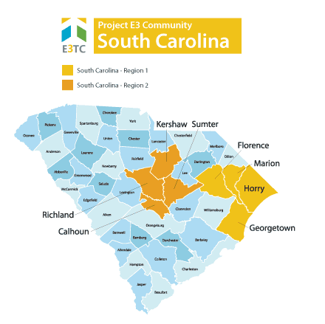

High Leverage Groups of National Applicability (HLGNA)
South Carolina’s focus populations included (a) women over the age of 18 with specific sensory impairments including blindness or other visual impairments, receiving Temporary Assistance for Needy Families (TANF), Supplemental Security Income (SSI), or Social Security Disability Insurance (SSDI); and (b) African-American males over the age of 18 with specific sensory impairments, including blindness or other visual impairments:
- Culturally diverse populations
- Consumers receiving federal financial assistance (TANF)
- Residents of rural and remote communities
- High school dropouts and functionally illiterate consumers
- Persons with multiple disabilities (e.g., deaf-blindness, HIV/AIDS with substance abuse)
- SSI and SSDI recipients, including subminimum-wage employees

Primary Challenges
Despite the provision of high-quality vocational rehabilitation services, individuals with disabilities within the Pee Dee and Midlands regions continued to experience high poverty and high unemployment. These outcomes persisted due to numerous barriers that existed to engaging in and completing vocational rehabilitation programming. These barriers included:
- Impact of rural environment on transportation, job opportunities, job diversity
- Geographic barriers to service provision and employment opportunities
- Limited awareness in the community of the services South Carolina Commission for the Blind and other service providers resulting in few applications for services relative to the number of individuals eligible for services
- Limited engagement in vocational rehabilitation services over concerns of loss of disability benefits
- Limited training for counselors in evidence-based practices
- Limited awareness of the distributed local labor market, employer expectations, and opportunities to develop home-based or self-employment jobs
- Limited successful employment histories
- Anchoring to geographic community that limits migration for work
- Seasonal employment opportunities associated with tourism

Specific Goal(s) for This Project
Project E3 provided South Carolina’s state Vocational Rehabilitation agencies and their partners with the skills and competencies needed to effectively and efficiently address barriers to competitive integrated employment and community integration encountered by persons with disabilities in these regions.
Our specific goals for this project were to:
- By the end of the first year, 25 individuals from each region would apply or return to vocational rehabilitation services.
- By the end of the second year, approximately 18 individuals from each region would be found eligible for services.

- By the end of the second year, the number of people who completed an Individualized Plan for Employment (IPE) would increase by 50%. Of those, the cases closed in competitive, integrated employment would increase by 25%.
- The project would develop a community consortium to direct, develop, and sustain services during the project and into the coming years.
The team leveraged promising practices, knowledge, and experience gained from this project to expand employment opportunities for individuals with disabilities from underserved and economically disadvantaged populations throughout South Carolina and across the United States.

Key Strategies to Address Barriers
Community Based Participatory Research (CBPR): To understand a community’s issues and concerns, one needs data and information both supplied by common data sources and interpreted by the community to better understand their issues and possible solutions to those issues. CBPR’s methodology is predicated on deep and extensive community involvement in the identification of issues and concerns and in the resolution of those issues and concerns.
Motivational Interviewing: Project E3 provided 2 days of training to all SCCB VR Counselors and Supervisors. Training included an MI toolkit and materials. SCCB had invited community partners including the general agency to attend, but only SCCB VR staff ended up attending. Staff use selective techniques.
Work Incentive Benefits Counseling: SC identified this as a key strategy to help clients understand the positive implications of pursuing competitive employment and the effects on benefits. Referrals increased after the training and SCCB now uses the state WIPA grant program.
Financial Literacy: SCCB modified and adapted the curriculum “Skills to Pay the Bills” for use in the standard EBMRCE curriculum. In addition, “Skills to Pay the Bills” was incorporated into their Summer Teens program and was incorporated into the new BRIDGE Program. SCCB decided to formally incorporate the “Your Money, Your Goals' ' curriculum into the formal class schedules at the EBMRCE.
Job Club: Following this training, SCCB established the BRIDGE Program (Building Readiness for Individualized Development of Gainful Employment). The BRIDGE program was designed to incorporate Job Club techniques and structures, soft skills training and Skills to Pay the Bills social skills training, and pre-apprenticeship to registered apprenticeship training activities.
Job Exploration Counseling: Career BOOST (Building Occupational Opportunities for Students in Transition). The program provides Self-Advocacy Training, Career Exploration Counseling, College and Post-Secondary Education Training Exploration, Work Readiness Training (Soft Skills), and Work Based Learning Experiences to students who are eligible or potentially eligible for VR services.

Site Partner Reflections
Site partners reflections focused primarily on (a) community-based partnerships, (b) an innovative approach to generating and utilizing a community resource list, (c) barriers to services, (d) training, and (e) sustainability.

Community-Based Partnerships
Enhanced community-based partnerships provide the strongest evidence of the success of Project E3 in South Carolina, particularly, partnerships with faith-based organizations. As faith-based organizations were included in trainings across sites (e.g., South Carolina Commission of the Blind), representatives were able to learn about the state-vocational rehabilitation services and also the services of other community-based organizations that assist in improving employment, health, and quality of life outcomes for persons with disabilities. Additionally, vocational rehabilitation services staff and administrators were invited to community events. One administrator states: “they actually let us come in and we had one meeting where we met with 400 pastors” to “explain the services that VR provided”.

Community Resource List
Generating a community based “resource list” was of critical importance for administrators. This resource list was not the typical listing of vendors that are appropriate for service coordination, but of key community stakeholders that could assist in connecting vocational rehabilitation services to the broader community of persons with disabilities. One administrator states: “the resource list was one in which we felt was really needed”. When representatives from the South Carolina Commission of the Blind and vocational rehabilitation directors were asked if they had community-based connections, the overwhelming response was no. Specifically, one administrator stated “they said they did not know key people like faith-based... or council people…so we felt that was something that would be needed in those areas”. Based on this resource list of community leaders, administrators were able to build more sustainable partnerships, beginning with a stakeholder conference.
Conference themes included empowerment and education and provided the necessary mechanism to solidify partnerships long-term.

Barriers to Services
Reported barriers to services included transportation, limited number of vocational rehabilitation counselors, technological/virtual outreach challenges, Transportation continued to be a major barrier to service provision in the rural areas of South Carolina. In order to address transportation barriers, particularly in light of the COVID-19 pandemic toward the end of the grant, more virtual outreach was needed. Virtual outreach and service provision can bridge the gap, but ensuring the consumers have access to the necessary technology (e.g., hardware, software, internet) remains a challenge.

Trainings
Additional training, targeted to both service providers and consumers, assisted in capacity building efforts. Primary training included (a) navigating Social Security and the vocational rehabilitation process, (b) engaging community leaders in connecting consumers to services, and © motivational interviewing skills. Particularly, the training on Social Security built capacity to alleviate the concerns of potential applicants who fear losing benefits if they seek employment. As stated by one administrator, stakeholders requested “more training on Social Security”, so administrators along with Project E3 staff (i.e., Dr. Tim Tansey) coordinated additional training to meet that need. There were other trainings with a specific emphasis on community leaders that could potentially bridge the outreach gap. An example of this training was “pastoral involvement in the VR process” with the goal of training faith-leaders on service provision so “the applications can be given to individuals who are in the church, who can then also make people aware of it in the churches and when they have meetings”. Lastly, the motivational interviewing skills for staff was beneficial as indicated in the following quote: “I think a lot of people really go a lot out of that, because I hear that come up often”.

Sustainability
Reflections on sustainability focused on maintaining, building upon, and updating the community resource list as this provides the framework for ensuring the sustainability of established partnerships and continued growth. Additionally, key themes from Project E3, such as empowerment, enabled administrators to include those elements in another funding mechanism from the U.S. Department of Education on disaster prevention.

Virginia

Summary of State Project
Virginia is located between the Atlantic Coast and the Appalachian Mountains in the Southeast. It is the 35th largest state by area. Forests cover 65% of the state and the climate is humid and fairly warm, with daytime temperatures ranging from the mid 40’s to the mid 80’s throughout the year. The five regions of the state include coastal plains, mountains, valleys and rivers.
Coal mining is an important part of the state’s economy, along with farming, business, and the military. Virginia is also known as “the Mother of Presidents” as eight U.S. Presidents were born there. The state has 30 National Park Service units, such as the Appalachian Trail and the Shenandoah National Park.
The southeastern region of Virginia is identified as the Hampton Roads Region. It is known for its large military presence, ice-free harbor, shipyards, coal piers, and miles of waterfront. All of these contribute to the diversity and stability of the region's economy.
Virginia was chosen as a targeted community through the Vocational Rehabilitation Technical Assistance Center: Targeted Communities (VR-TAC-TC) or Project E3. Project E3 partnered with State VR Agencies and local community partners to improve outreach and employment-related services to underserved people with disabilities in this community..

Project E3 Partner
The George Washington University

Targeted Communities
The state-federal vocational rehabilitation system in Virginia faced many challenges as it strove to serve people with significant disabilities and promote competitive integrated employment. Project E3 provided intensive technical assistance to the City of Martinsville and Henry County (Region 1) and the Hampton Roads Region (Region 2).

Virginia State Map Highlighting ITA Targeted Communities

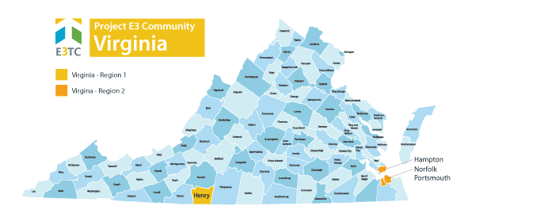

High Leverage Groups of National Applicability (HLGNA)
Virginia’s focus populations included (a) consumers with drug abuse and dependency; and (b) persons with mental illness. These populations were further characterized as:
- Persons with multiple disabilities
- Residents of rural and remote communities
- Subminimum Wage Employees
- SSI and SSDI recipients
- Consumers receiving federal financial assistance (TANF)

Key Information as of 2017 (Start of ITA)
- Highest Emergency Room Overdose Rate involving unintentional opioid, heroin, or “unknown substance” related overdoses in January 2017.
- Average wage for people with a substance abuse disability was significantly lower than the average hourly wage for consumers of all disabilities.
- Poverty rate of 23% in Martinsville and Henry County compared with 11.2% statewide and 11.3% nationally.
- Unemployment rate of 7% in Martinsville and Henry County compared with 3.6% statewide and 4.1% nationally.
- Only 1% of the eligible HLGNA population had applied for VR services in Martinsville and Henry County
- There were six operating sheltered workshops, the oldest and largest of which was located in Martinsville.

Primary Challenges
The combination of the challenges involved with living in poverty and other related factors created significant barriers for persons with disabilities living in Virginia including (a) a lack of information about disability and vocational rehabilitation resources; (b) limited transportation options; (c) discrimination or stigma surrounding substance abuse and dependence, and mental illness; (d) negative attitudes among employers toward employment of persons with disabilities; (e) lack of motivational supports; (f) fear of losing existing financial and health benefits due to employment; (g) loss of hope in light and low wage jobs and high unemployment; (h) lack of employment opportunities and skills gaps for the existing economy; and (i) over-reliance on non-integrated employment.

Specific Goal(s) for This Project
Project E3 provided Virginia’s state Vocational Rehabilitation agencies and their partners with the skills and competencies needed to effectively and efficiently address barriers to competitive integrated employment and community integration encountered by persons with disabilities in these regions.
The specific goals included:
- Increase participation in state vocational rehabilitation programs of people with disabilities from low-income communities.
- Increase the number and percentage of people with disabilities from low-income communities who complete their vocational rehabilitation program and achieve competitive integrated employment.
- Increase the support services provided by community agencies to individuals with disabilities from low-income communities who participate in the vocational rehabilitation program.
- Increase coordinated vocational rehabilitation program/community agency service delivery systems and strategies providing comprehensive support to individuals with disabilities from low-income communities who participate in the vocational rehabilitation program.
- Increase the regions’ rehabilitation rate by approximately 60% to be consistent with the statewide rehabilitation rate.
- Close the wage gap for targeted populations in the Hampton Roads Region to align with the statewide average wage for consumers with all disabilities.
- Cut the wage gap in half for targeted populations in Martinsville/Henry County

The team leveraged promising practices, knowledge, and experience gained from this project to expand employment opportunities for individuals with disabilities from underserved and economically disadvantaged populations throughout Virginia and across the United States.

Key Strategies to Address Barriers
The following strategies were developed and implemented to address the targeted populations' challenges and barriers to employment:

Community Based Participatory Research (CBPR): To understand a community’s issues and concerns, one needs data and information both supplied by common data sources and interpreted by the community to better understand their issues and possible solutions to those issues. CBPR’s methodology is predicated on deep and extensive community involvement in the identification of issues and concerns and in the resolution of those issues and concerns.
Community Outreach and Orientation: The goal of community outreach and orientation is increased referrals for vocational rehabilitation services from community-based organizations and applications from people with disabilities. To achieve this goal, developing relationships within local communities is essential. Community outreach and building knowledge about hiring people with disabilities is key.
Poverty and Disability: Bridges Out of Poverty - It is difficult for many individuals including professionals in the field to understand the extent of challenges facing individuals living in poverty and trying to work their way out of poverty. “Bridges Out of Poverty” is excellent training on cultural responsiveness for working with people and communities that experience poverty. It is a proprietary training program so for more information see aha! Process - Poverty Reduction Professional Development and Solutions (ahaprocess.com)
Financial Literacy Training: When persons with disabilities start their first job or return to work, many have limited understanding of basic financial principles which can increase their wealth and help them manage their income. George Washington University worked with Virginia’s targeted communities to train staff in financial wellness, financial goals, ABLE accounts, Social Security Work Incentives and Virginia’s DARS’ Financial Health Assessment, Benefits Planning and the “Your Money, Your Goals” toolkit from the Consumer Financial Protection Bureau. There was a partnership with the New York City Department of Consumer Affairs to train volunteers in their Financial Empowerment Counselor training.
Integrated Resource Teams: To overcome shortage of resources, overlapping services, lack of information, and coordinated planning, Integrated Resource Teams (IRTs) are an excellent way to structure collaborative working arrangements as well as consider options for the blending and braiding of services and funding. IRT membership depends on the locale and existing working relationships and can include Vocational Rehabilitation, education, social services, Workforce, faith- based organizations, mental health agencies, veteran’s agencies, etc.
Comprehensive Support Systems and Capacity Building: Community Academy – Not all potential community partners and community based organizations understand the intersection of poverty, disability and employment. The Community Academy is a good educational approach. A typical Academy has the following elements: Introduction of Community Academy concept, logistics, and implementation for both an “in person” and “virtual” Community Academy. Training participants will leave with step by step instructions on how to plan and carry out a Community Academy as well as tools, including a sample invitation, sample registration form, and suggested list of foundational organizations to participate, to support them in hosting their own Community.

Site Partner Reflections
Site partner reflections included a focus on community connections, an overall shift in perspective for vocational rehabilitation stakeholders, training, barriers, and sustainability.

Community Connections
At the beginning of the project, administrators and vocational rehabilitation involved staff, began with “the development of the advisory councils” and in one area joining “a historic group that had been meeting for years”. From those initial meetings, the commission and district director attended meetings which showed “that this agency was committed to try to make this work” and “added a little bit to the trust from partners to come together”. These stakeholder advisory groups provided the catalyst to fostering new and expanding existing community-based partnerships to improve services for consumers with disabilities in the targeted groups for Virginia. Representatives come from partner agencies such as social services, adult education, United Way, Virginia Career Works, etc.

Shift in Perspective
A major holistic takeaway from Project E3 was a shift of perspective for vocational rehabilitation service providers. One administrator states this project encouraged “shifting some of the thinking of staff…to view it from their [consumer] lens instead of ours”. For instance, if a consumer disconnects from services, “instead of thinking they’re non-compliant, oh, well, you know, let’s look at this, is there a different way we can approach that so that services are accessible”. Trainings in cultural competency and the intersection of disability and poverty provided the catalyst for this shift in perspective.

Trainings
Vocational rehabilitation staff participated in extensive training. One administrator states: “we did a lot of work around the intersection of disability and poverty, around poverty as a cultural competency”. When considering unsuccessful employment outcomes in the context of cultural competency: “lots of our partners, when you’ve worked in these fields for years and years and you’ve been…burned when you spent money and didn’t get an outcome, it’s easy to not think about poverty as its own form of a cultural competency and what trade-offs are we asking and expecting of the clients we’re trying to serve to get to this appointment or that”. Coordinated trainings with community partners “allowed people to talk through how we unintentionally and maybe through some implicit biases created additional barriers for individual cases in each of the systems” and help, people in a safe way see their role and as an institution see our role and what we can do differently. Other trainings included financial empowerment, Bridges Out of Poverty, and motivational interviewing. A major takeaway across trainings and programs implemented by community-based organizations, stakeholders began to realize “just because something doesn’t fit within our organization [implementing a specific training], if the larger community wants it and is going to use it and it’s going to help our clients, we want to try to be supportive at whatever level we can”.

Barriers:
Community-based agencies working in silos was the main barrier described by vocational rehabilitation administrators. One administrator states: “a barrier is that the client, you know, has to come to each agency separately, and one of the big things that we have learned and are trying to put in place and had put in place in many instances is having shared responsibility, shared collaboration of referrals so the client doesn’t have to go through each hoop for each agency”. Another identified barrier was resistance to some of the trainings, particularly the Bridges Out of Poverty training. This resistance was due to “the ongoing cost to be certified” and “it’s not evidence-based in its approach in certain ways” as indicated by partners within adult education. To combat this resistance, after providing training, vocational rehabilitation administrators and staff approached community providers with the perspective of “if you like it, use it” instead of trying to overly endorse use of the training.

Sustainability
In terms of sustainability, Virginia now has its own internal training entitled Community Financial Empowerment centered on treating poverty as a form of cultural competency, identifying hidden biases around working with people in poverty, behavioral economics, and reframing. Additionally, to promote sustainability, administrators “are developing a Google Drive with every document, every type of invitation, every how-to we’ve done” as a how-to guide for all state-vocational rehabilitation offices and community-based organizations. In the state’s strategic plan, administrators plan to “do a community academy once per year, and the suggestion from the council was that we do it around the time that budgets, agency budgets are completed so that we can get updated, new information and share those things”. Also, there is a plan to have biannual training and continue the advisory council.

Sustainability, Tools, and Resources

Community Based Participatory Research
- Presentation Slides: Community-Based Participatory Research

Community Outreach and Orientation
- Invitation to Participate and Application Process
- Statewide Roll-out Training Outline

Comprehensive Support Systems and Capacity Building
- Community Academy Agenda
- Invite to Community Academy
- Registration to Community Academy
- Sample Invite List Community Academy
- Presentation Slides: Community Academy

Disability and Poverty Training
- Presentation Slides: Disability and Poverty

Integrated Resource Teams
- Planning Form: Integrated Resource Teams
- Planning Form Example: Integrated Resource Teams
- Mapping Exercise: Integrated Resource Teams
- Presentation 4: Integrated Resource Teams
- Presentation 5: Integrated Resource Teams

This product was developed under a grant from the Department of Education, under Vocational Rehabilitation Technical Assistance Center-Targeted Communities, Assistance Listing Number 84.264F. However, those contents do not necessarily represent the policy of the Department of Education, and you should not assume endorsement by the Federal Government.

